**Database Management System 1**

**CPS 542 – Spring 2024**

**DATABASE DESIGN**

**OF**

**BLOOD BANK MANAGEMENT SYSTEM**

**(FINAL REPORT)**

**DATA ADDED, SQL QUERIES and**

**TABLES CREATED BY**

Yaswanth Ijjurotula – (1017455050)

Darshan Jigala Channa Reddy – (1017929330)

Vinitha Uppunuru – (1017928230)

Shayna Guilfoyle – (1014632130)

Sharanya Saravanan – (1017917990)

Nischay Kamshetty – (1017923540)

Under the Guidance of

**JIM BUCKLEY**

(DEPARTMENT OF COMPUTER SCIENCE)

**CONTENTS**

**INTRODUCTION 3**

Database Proposal 3

**DATABASE ENTITIES AND RELATIONSHIPS 3**

Entities 3

Relations 4

**ER MODEL 4**

Description 4

Entities 5

**ENTITY-RELATIONSHIP DIAGRAM 6**

**DATABASE SCHEMA DIAGRAM 7**

**REFERENTIAL INTEGRITY CONSTRAINTS 8**

**NORMALIZATION 9**

Database Normal Forms 9

**PHYSICAL MODEL 11**

**DATA INSERTION 15**

**TABLE VIEWS 45**

**TRANSACTIONS 57**

**CONCLUSION 68**

**INTRODUCTION**

**Database Proposal:**   
A manual approach to managing blood bank operations is outdated and inefficient. Implementing a database management system can enhance the process by efficiently handling blood stock levels, donor registration, recipient registration, and blood distribution. Manual tracking of blood stock, donor details, and blood distribution is inefficient and error-prone, potentially leading to wasted resources such as expired blood and blood shortages for patients in need. The proposed database includes 8 entities connected by 8 relationships. The system aims to facilitate the tracking and organization of blood donations, storage, and distribution. It is anticipated to enhance the accuracy and efficiency of blood inventory management, donor registration, and blood stock level monitoring. This system will contribute to the timely provision of safe blood to patients in need.

The scope of the database includes following functions:

* Hospital Management
* Patient Information
* Inventory Management
* Request Management
* Donor Information
* Blood Bank Information
* Blood Camp Information

**DATABASE ENTITIES AND RELATIONSHIPS**

**Entities:**

**Hospital:** An entity that represents different hospitals.

(**hospital_id**, h_phone, operation_hours, h_address, h_name)

**Patient:** An entity that stores details about patients and their association with a hospital.

(**patient_id**, name, gender, p_blood_group, mobile_number)

**Blood Camp:** An entity representing blood donation camps.

(**bc_id**, bc_operation_hours, bc_name, start_date, end_date)

**Blood_Stored:** An entity representing blood stored in different camps and their association with blood camps.

(**bs_id**, expiry_date, blood_type, stored_blood_quantity)

**Blood Bank:** An entity representing different blood banks.

(**bb_id**, bb_operation_hours, bb_phone, bb_name)

**Inventory:** An entity to make note of all the availability of different blood types and quantity to donate.

(**inventory_id**, quantity, blood_type, expiry_date)

**Request:** An entity to manage blood request from hospitals, blood banks and blood camps.

(**req_id**, req_quantity, blood_group)

**Donor:** An entity that has the information about blood donors and their association with blood banks and blood camps.

(**donor_id**, donor_name, gender, age, date_of_last_donation)

**Relations:**

1. Patient **admits** in Hospital
2. Hospital **sends** Request
3. Request **sent_to_bb** to Blood_Bank.
4. Request **sent_to_bc** to Blood_camp.
5. Blood bank **contains** Inventory.
6. Donor **donates_to_bb to** Bloodbank.
7. Donor **donates_to_bc to** Bloodcamp.
8. Bloodcamp **stores** Blood_Stored.

**ER MODEL**

**Description:**

The ER model for a blood bank database consists of several entities, including **Patient**, **Hospital**, **Donor**, **Blood_Camp**, **Blood_Bank**, **Inventory**, **Request**, and **Blood_Stored**. Each entity has its own set of attributes and relationships with other entities. The ER model provides a visual representation of the database schema, which is useful for designing and maintaining the blood bank database.

The database keeps track of information about patients who admit to hospitals and donors who provide blood to blood banks or blood camps. It also manages blood requests from hospitals and the storage and distribution of blood products.

When a patient admits to a hospital, their information is recorded in the database. Hospitals send requests for blood products to blood banks and blood camps. Donors provide blood to either blood banks or blood camps, and the database keeps track of donor information and donation history.

Blood banks manage blood inventory and fulfill requests from hospitals. They store blood products and track their expiration dates. Blood camps organize events for collecting blood from donors and storing it for future use.

**Entities:**

Hospital (**hospital_id**, h_phone, operation_hours, h_address, h_name)

Patient (**patient_id**, name, gender, p_blood_group, mobile_number)

Blood_Camp (**bc_id**, bc_operation_hours, bc_name, start_date, end_date)

Blood_stored (**bs_id**, expiry_date, blood_type, stored_blood_quantity)

Blood_bank (**bb_id**, bb_operation_hours, bb_phone, bb_name)

Inventory (**inventory_id**, quantity, blood_type, expiry_date)

Request (**req_id**, req_quantity, blood_group)

Donor (**donor_id**, donor_name, gender, age, date_of_last_donation)

**ENTITY-RELATIONSHIP DIAGRAM**

**DATABASE SCHEMA DIAGRAM**

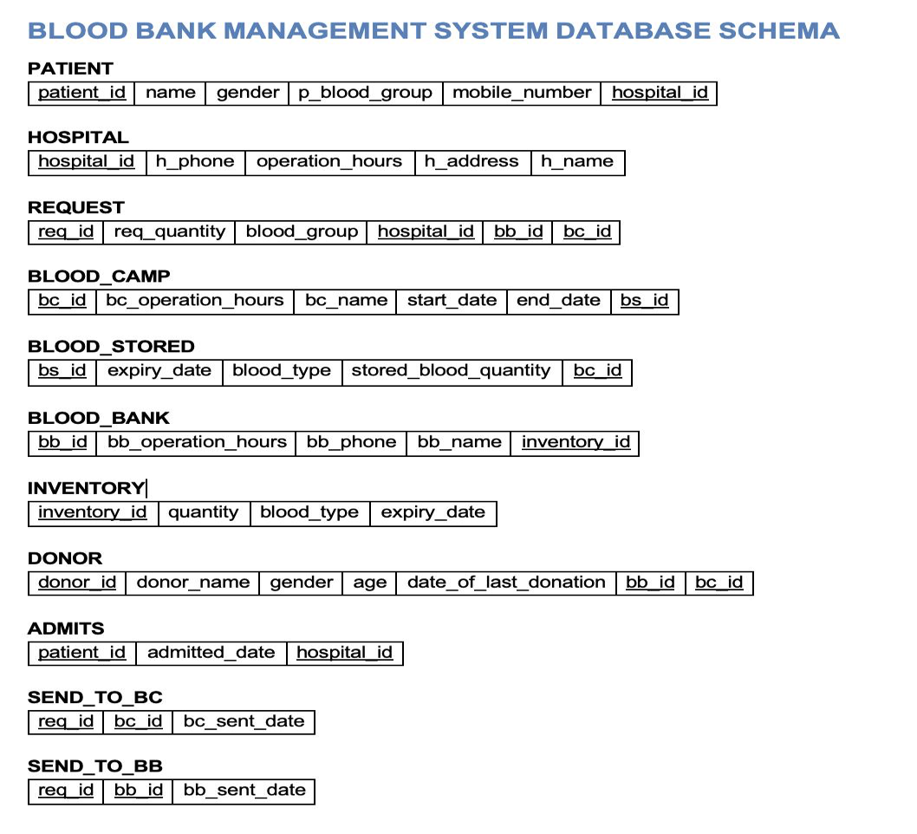

**REFERENTIAL INTEGRITY CONSTRAINTS**

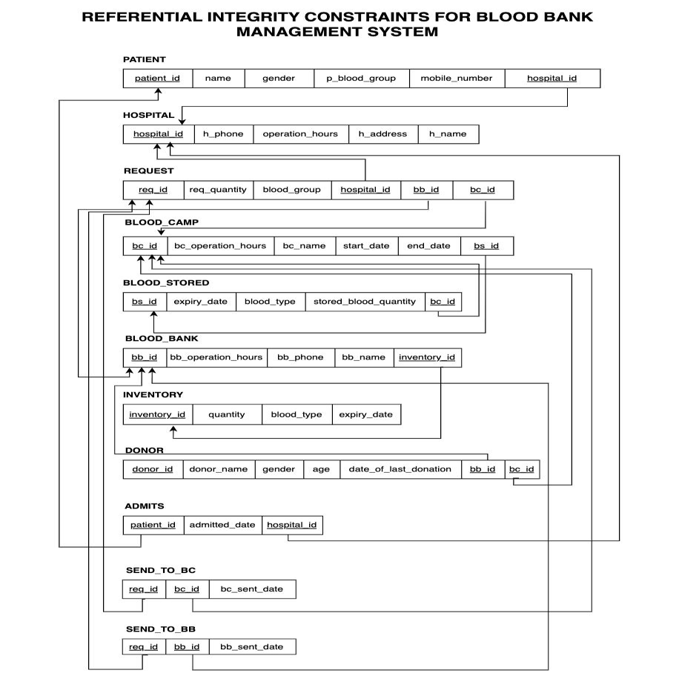

**NORMALIZATION**

Normalization is a database design approach focused on reducing data redundancy and resolving issues like Insertion, Update, and Deletion Anomalies within the database structure. This method involves splitting tables and creating relationships between them. In SQL, the main objective of normalization is to eliminate redundant data and ensure that information is stored logically and securely. There are six types of normalization in database systems, with the first three being the most commonly used. These normalization forms are as follows:

**Database Normal Forms**

Here is a list of Normal Forms

* 1NF (First Normal Form)
* 2NF (Second Normal Form)
* 3NF (Third Normal Form)

**1NF (First Normal Form)**

A database achieves First Normal Form when it adheres to the following principles:

* Every cell within a table holds only one value.
* Each record in the table is unique.

**2NF (Second Normal Form)**

For a database to meet the requirements of Second Normal Form:

* It must already satisfy the conditions of First Normal Form.
* All attributes not part of the primary key must be entirely dependent on the primary key.

**3NF (Third Normal Form)**

For a database to be considered in Third Normal Form:

* It must already meet the criteria of Fourth Normal Form.
* It should not have any non-key attributes that are dependent on other non-key attributes within the relation.

We have our database designed in such a way that it carefully follows all the rules of Normalization and maintains the Normal Forms while functioning.

**All tables are in 3NF.**

**PHYSICAL MODEL**

DROP TABLE Hospital CASCADE CONSTRAINTS;

CREATE TABLE Hospital (

hospital_id NUMBER,

h_name VARCHAR2(100),

h_phone VARCHAR2(20),

operation_hours VARCHAR2(100),

h_address VARCHAR2(200),

CONSTRAINT pk_hospital PRIMARY KEY (hospital_id)

);

DROP TABLE Patient CASCADE CONSTRAINTS;

CREATE TABLE Patient (

patient_id NUMBER,

FirstName VARCHAR2(100),

LastName VARCHAR2(100),

p_blood_group VARCHAR2(50),

gender VARCHAR2(50),

hos_id NUMBER,

CONSTRAINT pk_patient PRIMARY KEY (patient_id),

CONSTRAINT fk_hospital FOREIGN KEY (hos_id)

REFERENCES Hospital(hospital_id)

);

DROP TABLE MobileNumbers CASCADE CONSTRAINTS;

CREATE TABLE MobileNumbers (

mobile_id INT PRIMARY KEY,

p_id INT NOT NULL,

mobile_number VARCHAR2(20),

CONSTRAINT fk_p_id FOREIGN KEY (p_id)

REFERENCES Patient(patient_id)

ON DELETE CASCADE

);

DROP TABLE Blood_Camp CASCADE CONSTRAINTS;

CREATE TABLE Blood_Camp (

bc_id NUMBER NOT NULL,

bc_operation_hours VARCHAR2(100),

bc_name VARCHAR2(100),

start_date DATE,

end_date DATE,

PRIMARY KEY (bc_id)

);

DROP TABLE Blood_Stored CASCADE CONSTRAINTS;

CREATE TABLE Blood_Stored (

bs_id NUMBER NOT NULL,

expiry_date DATE,

blood_type VARCHAR2(10),

stored_blood_quantity NUMBER,

bc_id NUMBER,

CONSTRAINT pk_blood_stored PRIMARY KEY (bs_id),

CONSTRAINT fk_bc_id FOREIGN KEY (bc_id)

REFERENCES Blood_Camp(bc_id)

ON DELETE CASCADE

);

DROP TABLE Blood_Bank CASCADE CONSTRAINTS;

CREATE TABLE Blood_Bank (

bb_id NUMBER NOT NULL,

bb_operation_hours VARCHAR2(100),

bb_phone VARCHAR2(20),

bb_name VARCHAR2(100),

PRIMARY KEY (bb_id)

);

DROP TABLE Inventory CASCADE CONSTRAINTS;

CREATE TABLE Inventory (

inventory_id NUMBER NOT NULL,

quantity NUMBER,

blood_type VARCHAR2(10),

expiry_date DATE,

bb_id NUMBER,

PRIMARY KEY (inventory_id),

CONSTRAINT fk_bb_id FOREIGN KEY (bb_id)

REFERENCES Blood_Bank(bb_id)

ON DELETE CASCADE

);

DROP TABLE Request CASCADE CONSTRAINTS;

CREATE TABLE Request (

req_id NUMERIC NOT NULL,

req_quantity NUMERIC NOT NULL,

blood_group VARCHAR(10) NOT NULL,

hospital_id NUMERIC,

bb_id NUMERIC,

bc_id NUMERIC,

PRIMARY KEY (req_id),

CONSTRAINT fk_hospital_request FOREIGN KEY (hospital_id)

REFERENCES Hospital(hospital_id) ON DELETE CASCADE,

CONSTRAINT fk_blood_bank_request FOREIGN KEY (bb_id)

REFERENCES Blood_Bank(bb_id) ON DELETE CASCADE,

CONSTRAINT fk_blood_camp_request FOREIGN KEY (bc_id)

REFERENCES Blood_Camp(bc_id) ON DELETE CASCADE

);

DROP TABLE Donor CASCADE CONSTRAINTS;

CREATE TABLE Donor (

donor_id NUMBER NOT NULL,

donor_name VARCHAR2(100),

gender VARCHAR2(10),

age NUMBER,

date_of_last_donation DATE,

bb_id NUMBER,

bc_id NUMBER,

PRIMARY KEY (donor_id),

CONSTRAINT fk_blood_bank_donor FOREIGN KEY (bb_id)

REFERENCES Blood_Bank(bb_id) ON DELETE CASCADE,

CONSTRAINT fk_blood_camp_donor FOREIGN KEY (bc_id)

REFERENCES Blood_Camp(bc_id) ON DELETE CASCADE

);

DROP TABLE Admits CASCADE CONSTRAINTS;

CREATE TABLE Admits (

patient_id NUMBER NOT NULL,

admitted_date DATE,

hospital_id NUMBER NOT NULL,

PRIMARY KEY (patient_id, hospital_id),

CONSTRAINT fk_patient_admits FOREIGN KEY (patient_id)

REFERENCES Patient(patient_id),

CONSTRAINT fk_hospital_admits FOREIGN KEY (hospital_id)

REFERENCES Hospital(hospital_id)

);

DROP TABLE Send_to_bc CASCADE CONSTRAINTS;

CREATE TABLE Send_to_bc (

req_id NUMBER NOT NULL,

bc_id NUMBER NOT NULL,

bc_sent_date DATE,

PRIMARY KEY (req_id, bc_id),

CONSTRAINT fk_request_tobc FOREIGN KEY (req_id)

REFERENCES Request(req_id),

CONSTRAINT fk_blood_camp FOREIGN KEY (bc_id)

REFERENCES Blood_Camp(bc_id)

);

DROP TABLE Send_to_bb CASCADE CONSTRAINTS;

CREATE TABLE Send_to_bb (

req_id NUMBER NOT NULL,

bb_id NUMBER NOT NULL,

bb_sent_date DATE,

PRIMARY KEY( req_id, bb_id),

CONSTRAINT fk_request FOREIGN KEY (req_id)

REFERENCES Request(req_id),

CONSTRAINT fk_blood_bank_tobb FOREIGN KEY (bb_id)

REFERENCES Blood_Bank(bb_id)

);

DROP VIEW Patient_View;

CREATE VIEW Patient_View AS

SELECT FirstName, LastName, FirstName || ' ' || LastName AS Name

FROM Patient;

**DATA INSERTION**

**Hospital**

INSERT INTO Hospital (hospital_id, h_name, h_phone, operation_hours, h_address)

VALUES (1, 'City Hospital', '123-456-7890', '8:00 AM - 5:00 PM', '123 Main St, City');

INSERT INTO Hospital (hospital_id, h_name, h_phone, operation_hours, h_address)

VALUES (2, 'County Medical Center', '456-789-0123', '24/7', '456 Elm St, County');

INSERT INTO Hospital (hospital_id, h_name, h_phone, operation_hours, h_address)

VALUES (3, 'General Hospital', '789-012-3456', '9:00 AM - 7:00 PM', '789 Oak St, Town');

INSERT INTO Hospital (hospital_id, h_name, h_phone, operation_hours, h_address)

VALUES

(4, 'University Hospital', '012-345-6789', '10:00 AM - 6:00 PM', '456 Maple St, University');

INSERT INTO Hospital (hospital_id, h_name, h_phone, operation_hours, h_address)

VALUES (5, 'Community Hospital', '234-567-8901', '8:00 AM - 4:00 PM', '789 Pine St, Community');

INSERT INTO Hospital (hospital_id, h_name, h_phone, operation_hours, h_address)

VALUES (6, 'Veterans Hospital', '345-678-9012', '24/7', '123 Oak St, Veterans');

INSERT INTO Hospital (hospital_id, h_name, h_phone, operation_hours, h_address)

VALUES (7, 'Childrens Hospital', '111-222-3333', '9:00 AM - 5:00 PM', '456 Cedar St, Children');

INSERT INTO Hospital (hospital_id, h_name, h_phone, operation_hours, h_address)

VALUES (8, 'Medical Center', '567-890-1234', '8:00 AM - 6:00 PM', '789 Walnut St, Medical');

INSERT INTO Hospital (hospital_id, h_name, h_phone, operation_hours, h_address)

VALUES (9, 'Regional Hospital', '678-901-2345', '10:00 AM - 8:00 PM', '123 Pine St, Regional');

INSERT INTO Hospital (hospital_id, h_name, h_phone, operation_hours, h_address)

VALUES (10, 'Saint Mary Hospital', '444-555-6666', '7:00 AM - 3:00 PM', '456 Maple St, Saint Mary');

INSERT INTO Hospital (hospital_id, h_name, h_phone, operation_hours, h_address)

VALUES (11, 'Memorial Hospital', '890-123-4567', '8:00 AM - 4:00 PM', '789 Oak St, Memorial');

INSERT INTO Hospital (hospital_id, h_name, h_phone, operation_hours, h_address)

VALUES (12, 'Mercy Hospital', '901-234-5678', '24/7', '123 Pine St, Mercy');

INSERT INTO Hospital (hospital_id, h_name, h_phone, operation_hours, h_address)

VALUES (13, 'Parkview Hospital', '000-111-2222', '9:00 AM - 5:00 PM', '456 Cedar St, Parkview');

INSERT INTO Hospital (hospital_id, h_name, h_phone, operation_hours, h_address)

VALUES (14, 'St. Joseph Hospital', '999-000-1111', '8:00 AM - 6:00 PM', '789 Walnut St, St. Joseph');

INSERT INTO Hospital (hospital_id, h_name, h_phone, operation_hours, h_address)

VALUES (15, 'Northwest Hospital', '888-999-0000', '10:00 AM - 8:00 PM', '123 Pine St, Northwest');

INSERT INTO Hospital (hospital_id, h_name, h_phone, operation_hours, h_address)

VALUES (16, 'Community Medical Center', '777-888-9999', '7:00 AM - 3:00 PM', '456 Maple St, Community Medical');

INSERT INTO Hospital (hospital_id, h_name, h_phone, operation_hours, h_address)

VALUES (17, 'Baptist Hospital', '666-777-8888', '8:00 AM - 4:00 PM', '789 Oak St, Baptist');

INSERT INTO Hospital (hospital_id, h_name, h_phone, operation_hours, h_address)

VALUES (18, 'University Medical Center', '555-666-7777', '24/7', '123 Pine St, University Medical');

INSERT INTO Hospital (hospital_id, h_name, h_phone, operation_hours, h_address)

VALUES (19, 'Central Hospital', '443-555-6666', '9:00 AM - 5:00 PM', '456 Cedar St, Central');

INSERT INTO Hospital (hospital_id, h_name, h_phone, operation_hours, h_address)

VALUES (20, 'South Hospital', '333-444-5555', '8:00 AM - 6:00 PM', '789 Walnut St, South');

**Patient**

INSERT INTO Patient (patient_id, FirstName, LastName, p_blood_group, gender, hos_id)

VALUES (101, 'John', 'Doe', 'O+', 'Male', 1);

INSERT INTO Patient (patient_id, FirstName, LastName, p_blood_group, gender, hos_id)

VALUES (102, 'Jane', 'Smith', 'A-', 'Female', 1);

INSERT INTO Patient (patient_id, FirstName, LastName, p_blood_group, gender, hos_id)

VALUES (103, 'Michael', 'Johnson', 'AB+', 'Male', 2);

INSERT INTO Patient (patient_id, FirstName, LastName, p_blood_group, gender, hos_id)

VALUES (104, 'Emily', 'Brown', 'B+', 'Female', 2);

INSERT INTO Patient (patient_id, FirstName, LastName, p_blood_group, gender, hos_id)

VALUES (105, 'David', 'Lee', 'O-', 'Male', 3);

INSERT INTO Patient (patient_id, FirstName, LastName, p_blood_group, gender, hos_id)

VALUES (106, 'Sophia', 'Martinez', 'AB-', 'Female', 3);

INSERT INTO Patient (patient_id, FirstName, LastName, p_blood_group, gender, hos_id)

VALUES (107, 'Christopher', 'Garcia', 'A+', 'Male', 4);

INSERT INTO Patient (patient_id, FirstName, LastName, p_blood_group, gender, hos_id)

VALUES (108, 'Emma', 'Wilson', 'B-', 'Female', 4);

INSERT INTO Patient (patient_id, FirstName, LastName, p_blood_group, gender, hos_id)

VALUES (109, 'Ethan', 'Anderson', 'O+', 'Male', 5);

INSERT INTO Patient (patient_id, FirstName, LastName, p_blood_group, gender, hos_id)

VALUES (110, 'Olivia', 'Taylor', 'AB+', 'Female', 5);

INSERT INTO Patient (patient_id, FirstName, LastName, p_blood_group, gender, hos_id)

VALUES (111, 'Aiden', 'Clark', 'A-', 'Male', 6);

INSERT INTO Patient (patient_id, FirstName, LastName, p_blood_group, gender, hos_id)

VALUES (112, 'Mia', 'Rodriguez', 'O-', 'Female', 6);

INSERT INTO Patient (patient_id, FirstName, LastName, p_blood_group, gender, hos_id)

VALUES (113, 'Lucas', 'Martinez', 'B+', 'Male', 7);

INSERT INTO Patient (patient_id, FirstName, LastName, p_blood_group, gender, hos_id)

VALUES (114, 'Isabella', 'Lee', 'AB-', 'Female', 7);

INSERT INTO Patient (patient_id, FirstName, LastName, p_blood_group, gender, hos_id)

VALUES (115, 'Liam', 'Thompson', 'A+', 'Male', 8);

INSERT INTO Patient (patient_id, FirstName, LastName, p_blood_group, gender, hos_id)

VALUES (116, 'Charlotte', 'Hall', 'B-', 'Female', 8);

INSERT INTO Patient (patient_id, FirstName, LastName, p_blood_group, gender, hos_id)

VALUES (117, 'Noah', 'Garcia', 'O+', 'Male', 9);

INSERT INTO Patient (patient_id, FirstName, LastName, p_blood_group, gender, hos_id)

VALUES (118, 'Amelia', 'Brown', 'AB+', 'Female', 9);

INSERT INTO Patient (patient_id, FirstName, LastName, p_blood_group, gender, hos_id)

VALUES (119, 'James', 'Wilson', 'A-', 'Male', 10);

INSERT INTO Patient (patient_id, FirstName, LastName, p_blood_group, gender, hos_id)

VALUES (120, 'Ava', 'Anderson', 'B+', 'Female', 10);

**MobileNumbers**

INSERT INTO MobileNumbers (mobile_id, p_id, mobile_number)

VALUES (200, 107, '512-345-6789');

INSERT INTO MobileNumbers (mobile_id, p_id, mobile_number)

VALUES (201, 101, '523-456-7890');

INSERT INTO MobileNumbers (mobile_id, p_id, mobile_number)

VALUES (202, 102, '534-567-8901');

INSERT INTO MobileNumbers (mobile_id, p_id, mobile_number)

VALUES (203, 103, '545-678-9012');

INSERT INTO MobileNumbers (mobile_id, p_id, mobile_number)

VALUES (204, 104, '556-789-0123');

INSERT INTO MobileNumbers (mobile_id, p_id, mobile_number)

VALUES (205, 105, '567-890-1234');

INSERT INTO MobileNumbers (mobile_id, p_id, mobile_number)

VALUES (206, 106, '578-901-2345');

INSERT INTO MobileNumbers (mobile_id, p_id, mobile_number)

VALUES (207, 107, '589-012-3456');

INSERT INTO MobileNumbers (mobile_id, p_id, mobile_number)

VALUES (208, 108, '590-123-4567');

INSERT INTO MobileNumbers (mobile_id, p_id, mobile_number)

VALUES (209, 109, '501-234-5678');

INSERT INTO MobileNumbers (mobile_id, p_id, mobile_number)

VALUES (210, 110, '502-345-6789');

INSERT INTO MobileNumbers (mobile_id, p_id, mobile_number)

VALUES (211, 111, '503-456-7890');

INSERT INTO MobileNumbers (mobile_id, p_id, mobile_number)

VALUES (212, 112, '504-567-8901');

INSERT INTO MobileNumbers (mobile_id, p_id, mobile_number)

VALUES (213, 113, '505-678-9012');

INSERT INTO MobileNumbers (mobile_id, p_id, mobile_number)

VALUES (214, 114, '506-789-0123');

INSERT INTO MobileNumbers (mobile_id, p_id, mobile_number)

VALUES (215, 115, '507-890-1234');

INSERT INTO MobileNumbers (mobile_id, p_id, mobile_number)

VALUES (216, 116, '508-901-2345');

INSERT INTO MobileNumbers (mobile_id, p_id, mobile_number)

VALUES (217, 117, '509-012-3456');

INSERT INTO MobileNumbers (mobile_id, p_id, mobile_number)

VALUES (218, 118, '510-123-4567');

INSERT INTO MobileNumbers (mobile_id, p_id, mobile_number)

VALUES (219, 119, '511-234-5678');

INSERT INTO MobileNumbers (mobile_id, p_id, mobile_number)

VALUES (220, 108, '513-456-7890');

INSERT INTO MobileNumbers (mobile_id, p_id, mobile_number)

VALUES (221, 103, '514-567-8901');

INSERT INTO MobileNumbers (mobile_id, p_id, mobile_number)

VALUES (222, 106, '515-678-9012');

INSERT INTO MobileNumbers (mobile_id, p_id, mobile_number)

VALUES (223, 110, '516-789-0123');

INSERT INTO MobileNumbers (mobile_id, p_id, mobile_number)

VALUES (224, 114, '517-890-1234');

**Blood_Camp**

INSERT INTO Blood_Camp (bc_id, bc_operation_hours, bc_name, start_date, end_date)

VALUES (300, '8:00 AM - 5:00 PM', 'Blood Drive 1', '05/15/2024', '05/20/2024');

INSERT INTO Blood_Camp (bc_id, bc_operation_hours, bc_name, start_date, end_date)

VALUES (301, '9:00 AM - 6:00 PM', 'Blood Donation Camp 2', '06/01/2024', '06/05/2024');

INSERT INTO Blood_Camp (bc_id, bc_operation_hours, bc_name, start_date, end_date)

VALUES (302, '10:00 AM - 4:00 PM', 'Health Fair Blood Donation', '06/15/2024', '06/20/2024');

INSERT INTO Blood_Camp (bc_id, bc_operation_hours, bc_name, start_date, end_date)

VALUES (303, '7:00 AM - 3:00 PM', 'Community Blood Drive', '07/01/2024', '07/05/2024');

INSERT INTO Blood_Camp (bc_id, bc_operation_hours, bc_name, start_date, end_date)

VALUES (304, '8:00 AM - 4:00 PM', 'Blood Donor Clinic', '07/15/2024', '07/20/2024');

INSERT INTO Blood_Camp (bc_id, bc_operation_hours, bc_name, start_date, end_date)

VALUES (305, '9:00 AM - 5:00 PM', 'Blood Donation Event', '08/01/2024', '08/05/2024');

INSERT INTO Blood_Camp (bc_id, bc_operation_hours, bc_name, start_date, end_date)

VALUES (306, '10:00 AM - 6:00 PM', 'Blood Drive 2', '08/15/2024', '08/20/2024');

INSERT INTO Blood_Camp (bc_id, bc_operation_hours, bc_name, start_date, end_date)

VALUES (307, '8:00 AM - 5:00 PM', 'Health Fair Blood Drive', '09/01/2024', '09/05/2024');

INSERT INTO Blood_Camp (bc_id, bc_operation_hours, bc_name, start_date, end_date)

VALUES (308, '9:00 AM - 6:00 PM', 'Community Blood Donation', '09/15/2024', '09/20/2024');

INSERT INTO Blood_Camp (bc_id, bc_operation_hours, bc_name, start_date, end_date)

VALUES (309, '7:00 AM - 3:00 PM', 'Blood Drive 3', '10/01/2024', '10/05/2024');

INSERT INTO Blood_Camp (bc_id, bc_operation_hours, bc_name, start_date, end_date)

VALUES (310, '8:00 AM - 4:00 PM', 'Mobile Blood Donation', '10/15/2024', '10/20/2024');

INSERT INTO Blood_Camp (bc_id, bc_operation_hours, bc_name, start_date, end_date)

VALUES (311, '9:00 AM - 5:00 PM', 'Blood Donor Day', '11/01/2024', '11/05/2024');

INSERT INTO Blood_Camp (bc_id, bc_operation_hours, bc_name, start_date, end_date)

VALUES (312, '10:00 AM - 6:00 PM', 'Blood Drive 4', '11/15/2024', '11/20/2024');

INSERT INTO Blood_Camp (bc_id, bc_operation_hours, bc_name, start_date, end_date)

VALUES (313, '8:00 AM - 5:00 PM', 'Blood Donation Fair', '12/01/2024', '12/05/2024');

INSERT INTO Blood_Camp (bc_id, bc_operation_hours, bc_name, start_date, end_date)

VALUES (314, '9:00 AM - 6:00 PM', 'Blood Drive 5', '12/15/2024', '12/20/2024');

INSERT INTO Blood_Camp (bc_id, bc_operation_hours, bc_name, start_date, end_date)

VALUES (315, '7:00 AM - 3:00 PM', 'Community Blood Donor Day', '01/01/2025', '01/05/2025');

INSERT INTO Blood_Camp (bc_id, bc_operation_hours, bc_name, start_date, end_date)

VALUES (316, '8:00 AM - 4:00 PM', 'Blood Donation Marathon', '01/15/2025', '01/20/2025');

INSERT INTO Blood_Camp (bc_id, bc_operation_hours, bc_name, start_date, end_date)

VALUES (317, '9:00 AM - 5:00 PM', 'Blood Drive 6', '02/01/2025', '02/05/2025');

INSERT INTO Blood_Camp (bc_id, bc_operation_hours, bc_name, start_date, end_date)

VALUES (318, '10:00 AM - 6:00 PM', 'Blood Donor Festival', '02/15/2025', '02/20/2025');

INSERT INTO Blood_Camp (bc_id, bc_operation_hours, bc_name, start_date, end_date)

VALUES (319, '8:00 AM - 5:00 PM', 'Mobile Blood Drive', '03/01/2025', '03/05/2025');

**Blood_Stored**

INSERT INTO Blood_Stored (bs_id, expiry_date, blood_type, stored_blood_quantity, bc_id)

VALUES (401, '05/15/2024', 'A+', 100, 300);

INSERT INTO Blood_Stored (bs_id, expiry_date, blood_type, stored_blood_quantity, bc_id)

VALUES (402, '05/15/2024', 'A-', 100, 300);

INSERT INTO Blood_Stored (bs_id, expiry_date, blood_type, stored_blood_quantity, bc_id)

VALUES (403, '05/15/2024', 'B+', 100, 300);

INSERT INTO Blood_Stored (bs_id, expiry_date, blood_type, stored_blood_quantity, bc_id)

VALUES (404, '05/15/2024', 'B-', 100, 300);

INSERT INTO Blood_Stored (bs_id, expiry_date, blood_type, stored_blood_quantity, bc_id)

VALUES (405, '05/15/2024', 'AB+', 100, 300);

INSERT INTO Blood_Stored (bs_id, expiry_date, blood_type, stored_blood_quantity, bc_id)

VALUES (406, '05/15/2024', 'AB-', 100, 300);

INSERT INTO Blood_Stored (bs_id, expiry_date, blood_type, stored_blood_quantity, bc_id)

VALUES (407, '05/15/2024', 'O+', 100, 300);

INSERT INTO Blood_Stored (bs_id, expiry_date, blood_type, stored_blood_quantity, bc_id)

VALUES (408, '05/15/2024', 'O-', 100, 300);

INSERT INTO Blood_Stored (bs_id, expiry_date, blood_type, stored_blood_quantity, bc_id)

VALUES (409, '06/20/2024', 'A+', 150, 301);

INSERT INTO Blood_Stored (bs_id, expiry_date, blood_type, stored_blood_quantity, bc_id)

VALUES (410, '06/20/2024', 'A-', 150, 301);

INSERT INTO Blood_Stored (bs_id, expiry_date, blood_type, stored_blood_quantity, bc_id)

VALUES (411, '06/20/2024', 'B+', 150, 301);

INSERT INTO Blood_Stored (bs_id, expiry_date, blood_type, stored_blood_quantity, bc_id)

VALUES (412, '06/20/2024', 'B-', 150, 301);

INSERT INTO Blood_Stored (bs_id, expiry_date, blood_type, stored_blood_quantity, bc_id)

VALUES (413, '06/20/2024', 'AB+', 150, 301);

INSERT INTO Blood_Stored (bs_id, expiry_date, blood_type, stored_blood_quantity, bc_id)

VALUES (414, '06/20/2024', 'AB-', 150, 301);

INSERT INTO Blood_Stored (bs_id, expiry_date, blood_type, stored_blood_quantity, bc_id)

VALUES (415, '06/20/2024', 'O+', 150, 301);

INSERT INTO Blood_Stored (bs_id, expiry_date, blood_type, stored_blood_quantity, bc_id)

VALUES (416, '06/20/2024', 'O-', 150, 301);

INSERT INTO Blood_Stored (bs_id, expiry_date, blood_type, stored_blood_quantity, bc_id)

VALUES (417, '07/10/2024', 'A+', 200, 302);

INSERT INTO Blood_Stored (bs_id, expiry_date, blood_type, stored_blood_quantity, bc_id)

VALUES (418, '07/10/2024', 'A-', 200, 302);

INSERT INTO Blood_Stored (bs_id, expiry_date, blood_type, stored_blood_quantity, bc_id)

VALUES (419, '07/10/2024', 'B+', 200, 302);

INSERT INTO Blood_Stored (bs_id, expiry_date, blood_type, stored_blood_quantity, bc_id)

VALUES (420, '07/10/2024', 'B-', 200, 302);

INSERT INTO Blood_Stored (bs_id, expiry_date, blood_type, stored_blood_quantity, bc_id)

VALUES (421, '07/10/2024', 'AB+', 200, 302);

INSERT INTO Blood_Stored (bs_id, expiry_date, blood_type, stored_blood_quantity, bc_id)

VALUES (422, '07/10/2024', 'AB-', 200, 302);

INSERT INTO Blood_Stored (bs_id, expiry_date, blood_type, stored_blood_quantity, bc_id)

VALUES (423, '07/10/2024', 'O+', 200, 302);

INSERT INTO Blood_Stored (bs_id, expiry_date, blood_type, stored_blood_quantity, bc_id)

VALUES (424, '07/10/2024', 'O-', 200, 302);

INSERT INTO Blood_Stored (bs_id, expiry_date, blood_type, stored_blood_quantity, bc_id)

VALUES (425, '08/05/2024', 'A+', 120, 303);

INSERT INTO Blood_Stored (bs_id, expiry_date, blood_type, stored_blood_quantity, bc_id)

VALUES (426, '08/05/2024', 'A-', 120, 303);

INSERT INTO Blood_Stored (bs_id, expiry_date, blood_type, stored_blood_quantity, bc_id)

VALUES (427, '08/05/2024', 'B+', 120, 303);

INSERT INTO Blood_Stored (bs_id, expiry_date, blood_type, stored_blood_quantity, bc_id)

VALUES (428, '08/05/2024', 'B-', 120, 303);

INSERT INTO Blood_Stored (bs_id, expiry_date, blood_type, stored_blood_quantity, bc_id)

VALUES (429, '08/05/2024', 'AB+', 120, 303);

INSERT INTO Blood_Stored (bs_id, expiry_date, blood_type, stored_blood_quantity, bc_id)

VALUES (430, '08/05/2024', 'AB-', 120, 303);

INSERT INTO Blood_Stored (bs_id, expiry_date, blood_type, stored_blood_quantity, bc_id)

VALUES (431, '08/05/2024', 'O+', 120, 303);

INSERT INTO Blood_Stored (bs_id, expiry_date, blood_type, stored_blood_quantity, bc_id)

VALUES (432, '08/05/2024', 'O-', 120, 303);

INSERT INTO Blood_Stored (bs_id, expiry_date, blood_type, stored_blood_quantity, bc_id)

VALUES (433, '09/18/2024', 'A+', 180, 304);

INSERT INTO Blood_Stored (bs_id, expiry_date, blood_type, stored_blood_quantity, bc_id)

VALUES (434, '09/18/2024', 'A-', 180, 304);

INSERT INTO Blood_Stored (bs_id, expiry_date, blood_type, stored_blood_quantity, bc_id)

VALUES (435, '09/18/2024', 'B+', 180, 304);

INSERT INTO Blood_Stored (bs_id, expiry_date, blood_type, stored_blood_quantity, bc_id)

VALUES (436, '09/18/2024', 'B-', 180, 304);

INSERT INTO Blood_Stored (bs_id, expiry_date, blood_type, stored_blood_quantity, bc_id)

VALUES (437, '09/18/2024', 'AB+', 180, 304);

INSERT INTO Blood_Stored (bs_id, expiry_date, blood_type, stored_blood_quantity, bc_id)

VALUES (438, '09/18/2024', 'AB-', 180, 304);

INSERT INTO Blood_Stored (bs_id, expiry_date, blood_type, stored_blood_quantity, bc_id)

VALUES (439, '09/18/2024', 'O+', 180, 304);

INSERT INTO Blood_Stored (bs_id, expiry_date, blood_type, stored_blood_quantity, bc_id)

VALUES (440, '09/18/2024', 'O-', 180, 304);

INSERT INTO Blood_Stored (bs_id, expiry_date, blood_type, stored_blood_quantity, bc_id)

VALUES (441, '10/25/2024', 'A+', 50, 305);

INSERT INTO Blood_Stored (bs_id, expiry_date, blood_type, stored_blood_quantity, bc_id)

VALUES (442, '10/25/2024', 'A-', 50, 305);

INSERT INTO Blood_Stored (bs_id, expiry_date, blood_type, stored_blood_quantity, bc_id)

VALUES (443, '10/25/2024', 'B+', 50, 305);

INSERT INTO Blood_Stored (bs_id, expiry_date, blood_type, stored_blood_quantity, bc_id)

VALUES (444, '10/25/2024', 'B-', 50, 305);

INSERT INTO Blood_Stored (bs_id, expiry_date, blood_type, stored_blood_quantity, bc_id)

VALUES (445, '10/25/2024', 'AB+', 50, 305);

INSERT INTO Blood_Stored (bs_id, expiry_date, blood_type, stored_blood_quantity, bc_id)

VALUES (446, '10/25/2024', 'AB-', 50, 305);

INSERT INTO Blood_Stored (bs_id, expiry_date, blood_type, stored_blood_quantity, bc_id)

VALUES (447, '10/25/2024', 'O+', 50, 305);

INSERT INTO Blood_Stored (bs_id, expiry_date, blood_type, stored_blood_quantity, bc_id)

VALUES (448, '10/25/2024', 'O-', 50, 305);

INSERT INTO Blood_Stored (bs_id, expiry_date, blood_type, stored_blood_quantity, bc_id)

VALUES (449, '11/30/2024', 'A+', 0, 306);

INSERT INTO Blood_Stored (bs_id, expiry_date, blood_type, stored_blood_quantity, bc_id)

VALUES (450, '11/30/2024', 'A-', 0, 306);

INSERT INTO Blood_Stored (bs_id, expiry_date, blood_type, stored_blood_quantity, bc_id)

VALUES (451, '11/30/2024', 'B+', 0, 306);

INSERT INTO Blood_Stored (bs_id, expiry_date, blood_type, stored_blood_quantity, bc_id)

VALUES (452, '11/30/2024', 'B-', 0, 306);

INSERT INTO Blood_Stored (bs_id, expiry_date, blood_type, stored_blood_quantity, bc_id)

VALUES (453, '11/30/2024', 'AB+', 0, 306);

INSERT INTO Blood_Stored (bs_id, expiry_date, blood_type, stored_blood_quantity, bc_id)

VALUES (454, '11/30/2024', 'AB-', 0, 306);

INSERT INTO Blood_Stored (bs_id, expiry_date, blood_type, stored_blood_quantity, bc_id)

VALUES (455, '11/30/2024', 'O+', 0, 306);

INSERT INTO Blood_Stored (bs_id, expiry_date, blood_type, stored_blood_quantity, bc_id)

VALUES (456, '11/30/2024', 'O-', 0, 306);

INSERT INTO Blood_Stored (bs_id, expiry_date, blood_type, stored_blood_quantity, bc_id)

VALUES (457, '01/15/2025', 'A+', 0, 307);

INSERT INTO Blood_Stored (bs_id, expiry_date, blood_type, stored_blood_quantity, bc_id)

VALUES (458, '01/15/2025', 'A-', 0, 307);

INSERT INTO Blood_Stored (bs_id, expiry_date, blood_type, stored_blood_quantity, bc_id)

VALUES (459, '01/15/2025', 'B+', 0, 307);

INSERT INTO Blood_Stored (bs_id, expiry_date, blood_type, stored_blood_quantity, bc_id)

VALUES (460, '01/15/2025', 'B-', 0, 307);

INSERT INTO Blood_Stored (bs_id, expiry_date, blood_type, stored_blood_quantity, bc_id)

VALUES (461, '01/15/2025', 'AB+', 0, 307);

INSERT INTO Blood_Stored (bs_id, expiry_date, blood_type, stored_blood_quantity, bc_id)

VALUES (462, '01/15/2025', 'AB-', 0, 307);

INSERT INTO Blood_Stored (bs_id, expiry_date, blood_type, stored_blood_quantity, bc_id)

VALUES (463, '01/15/2025', 'O+', 0, 307);

INSERT INTO Blood_Stored (bs_id, expiry_date, blood_type, stored_blood_quantity, bc_id)

VALUES (464, '01/15/2025', 'O-', 0, 307);

INSERT INTO Blood_Stored (bs_id, expiry_date, blood_type, stored_blood_quantity, bc_id)

VALUES (465, '03/10/2025', 'A+', 0, 308);

INSERT INTO Blood_Stored (bs_id, expiry_date, blood_type, stored_blood_quantity, bc_id)

VALUES (466, '03/10/2025', 'A-', 0, 308);

INSERT INTO Blood_Stored (bs_id, expiry_date, blood_type, stored_blood_quantity, bc_id)

VALUES (467, '03/10/2025', 'B+', 0, 308);

INSERT INTO Blood_Stored (bs_id, expiry_date, blood_type, stored_blood_quantity, bc_id)

VALUES (468, '03/10/2025', 'B-', 0, 308);

INSERT INTO Blood_Stored (bs_id, expiry_date, blood_type, stored_blood_quantity, bc_id)

VALUES (469, '03/10/2025', 'AB+', 0, 308);

INSERT INTO Blood_Stored (bs_id, expiry_date, blood_type, stored_blood_quantity, bc_id)

VALUES (470, '03/10/2025', 'AB-', 0, 308);

INSERT INTO Blood_Stored (bs_id, expiry_date, blood_type, stored_blood_quantity, bc_id)

VALUES (471, '03/10/2025', 'O+', 0, 308);

INSERT INTO Blood_Stored (bs_id, expiry_date, blood_type, stored_blood_quantity, bc_id)

VALUES (472, '03/10/2025', 'O-', 0, 308);

INSERT INTO Blood_Stored (bs_id, expiry_date, blood_type, stored_blood_quantity, bc_id)

VALUES (473, '04/20/2025', 'A+', 0, 309);

INSERT INTO Blood_Stored (bs_id, expiry_date, blood_type, stored_blood_quantity, bc_id)

VALUES (474, '04/20/2025', 'A-', 0, 309);

INSERT INTO Blood_Stored (bs_id, expiry_date, blood_type, stored_blood_quantity, bc_id)

VALUES (475, '04/20/2025', 'B+', 0, 309);

INSERT INTO Blood_Stored (bs_id, expiry_date, blood_type, stored_blood_quantity, bc_id)

VALUES (476, '04/20/2025', 'B-', 0, 309);

INSERT INTO Blood_Stored (bs_id, expiry_date, blood_type, stored_blood_quantity, bc_id)

VALUES (477, '04/20/2025', 'AB+', 0, 309);

INSERT INTO Blood_Stored (bs_id, expiry_date, blood_type, stored_blood_quantity, bc_id)

VALUES (478, '04/20/2025', 'AB-', 0, 309);

INSERT INTO Blood_Stored (bs_id, expiry_date, blood_type, stored_blood_quantity, bc_id)

VALUES (479, '04/20/2025', 'O+', 0, 309);

INSERT INTO Blood_Stored (bs_id, expiry_date, blood_type, stored_blood_quantity, bc_id) VALUES (480, '04/20/2025', 'O-', 0, 309);

**Blood_Bank:**

INSERT INTO Blood_Bank (bb_id, bb_operation_hours, bb_phone, bb_name)

VALUES (500, 'Monday-Friday: 9am-5pm', '7372887890', 'Red Cross Blood Bank');

INSERT INTO Blood_Bank (bb_id, bb_operation_hours, bb_phone, bb_name)

VALUES (501, 'Monday-Saturday: 8am-6pm', '7372887690', 'Community Blood Center');

INSERT INTO Blood_Bank (bb_id, bb_operation_hours, bb_phone, bb_name)

VALUES (502, 'Monday-Friday: 10am-4pm', '7372587890', 'LifeStream Blood Bank');

INSERT INTO Blood_Bank (bb_id, bb_operation_hours, bb_phone, bb_name)

VALUES (503, 'Monday-Thursday: 8:30am-4:30pm', '2372887890', 'Bloodworks Northwest');

INSERT INTO Blood_Bank (bb_id, bb_operation_hours, bb_phone, bb_name)

VALUES (504, 'Monday-Friday: 9am-5pm', '7372887892', 'New York Blood Center');

INSERT INTO Blood_Bank (bb_id, bb_operation_hours, bb_phone, bb_name)

VALUES (505, 'Monday-Friday: 8am-4pm', '7372887893', 'Stanford Blood Center');

INSERT INTO Blood_Bank (bb_id, bb_operation_hours, bb_phone, bb_name)

VALUES (506, 'Monday-Friday: 9am-5pm', '7372887894', 'Vitalant Blood Donation Center');

INSERT INTO Blood_Bank (bb_id, bb_operation_hours, bb_phone, bb_name)

VALUES (507, 'Monday-Friday: 8am-4pm', '7372887895', 'American Red Cross');

INSERT INTO Blood_Bank (bb_id, bb_operation_hours, bb_phone, bb_name)

VALUES (508, 'Monday-Saturday: 9am-5pm', '7372887896', 'Memorial Blood Centers');

INSERT INTO Blood_Bank (bb_id, bb_operation_hours, bb_phone, bb_name)

VALUES (509, 'Monday-Friday: 10am-6pm', '7372887897', 'Blood Bank of Hawaii');

INSERT INTO Blood_Bank (bb_id, bb_operation_hours, bb_phone, bb_name)

VALUES (510, 'Monday-Friday: 8am-4pm', '7372887891', 'Hoxworth Blood Center');

INSERT INTO Blood_Bank (bb_id, bb_operation_hours, bb_phone, bb_name)

VALUES (511, 'Monday-Thursday: 9am-5pm', '7372887898', 'Gulf Coast Regional Blood Center');

INSERT INTO Blood_Bank (bb_id, bb_operation_hours, bb_phone, bb_name)

VALUES (512, 'Monday-Friday: 9am-5pm', '7372887899', 'Blood Connection');

INSERT INTO Blood_Bank (bb_id, bb_operation_hours, bb_phone, bb_name)

VALUES (513, 'Monday-Friday: 8am-4pm', '9374226594', 'Michigan Blood');

INSERT INTO Blood_Bank (bb_id, bb_operation_hours, bb_phone, bb_name)

VALUES (514, 'Monday-Saturday: 9am-5pm', '9374226593', 'BloodSource');

INSERT INTO Blood_Bank (bb_id, bb_operation_hours, bb_phone, bb_name)

VALUES (515, 'Monday-Friday: 10am-4pm', '9374226592', 'Blood Bank of Delmarva');

INSERT INTO Blood_Bank (bb_id, bb_operation_hours, bb_phone, bb_name)

VALUES (516, 'Monday-Friday: 9am-5pm', '9374226591', 'LifeShare Blood Center');

INSERT INTO Blood_Bank (bb_id, bb_operation_hours, bb_phone, bb_name)

VALUES (517, 'Monday-Friday: 8am-4pm', '9374226595', 'Mississippi Valley Regional Blood Center');

INSERT INTO Blood_Bank (bb_id, bb_operation_hours, bb_phone, bb_name)

VALUES (518, 'Monday-Thursday: 9am-5pm', '9374226596', 'Oklahoma Blood Institute');

INSERT INTO Blood_Bank (bb_id, bb_operation_hours, bb_phone, bb_name)

VALUES (519, 'Monday-Friday: 8am-4pm', '9374226597', 'Rock River Valley Blood Center');

**Inventory**

INSERT INTO Inventory (inventory_id, quantity, blood_type, expiry_date, bb_id)

VALUES (600, 100, 'A+', '05/15/2024', 500);

INSERT INTO Inventory (inventory_id, quantity, blood_type, expiry_date, bb_id)

VALUES (601, 100, 'A-', '05/15/2024', 500);

INSERT INTO Inventory (inventory_id, quantity, blood_type, expiry_date, bb_id)

VALUES (602, 100, 'B+', '05/15/2024', 500);

INSERT INTO Inventory (inventory_id, quantity, blood_type, expiry_date, bb_id)

VALUES (603, 0, 'B-', '05/15/2024', 500);

INSERT INTO Inventory (inventory_id, quantity, blood_type, expiry_date, bb_id)

VALUES (604, 0, 'AB+', '05/15/2024', 500);

INSERT INTO Inventory (inventory_id, quantity, blood_type, expiry_date, bb_id)

VALUES (605, 100, 'AB-', '05/15/2024', 500);

INSERT INTO Inventory (inventory_id, quantity, blood_type, expiry_date, bb_id)

VALUES (606, 100, 'O+', '05/15/2024', 500);

INSERT INTO Inventory (inventory_id, quantity, blood_type, expiry_date, bb_id)

VALUES (607, 0, 'O-', '05/15/2024', 500);

INSERT INTO Inventory (inventory_id, quantity, blood_type, expiry_date, bb_id)

VALUES (608, 150, 'A+', '06/20/2024', 501);

INSERT INTO Inventory (inventory_id, quantity, blood_type, expiry_date, bb_id)

VALUES (609, 150, 'A-', '06/20/2024', 501);

INSERT INTO Inventory (inventory_id, quantity, blood_type, expiry_date, bb_id)

VALUES (610, 150, 'B+', '06/20/2024', 501);

INSERT INTO Inventory (inventory_id, quantity, blood_type, expiry_date, bb_id)

VALUES (611, 0, 'B-', '06/20/2024', 501);

INSERT INTO Inventory (inventory_id, quantity, blood_type, expiry_date, bb_id)

VALUES (612, 150, 'AB+', '06/20/2024', 501);

INSERT INTO Inventory (inventory_id, quantity, blood_type, expiry_date, bb_id)

VALUES (613, 0, 'AB-', '06/20/2024', 501);

INSERT INTO Inventory (inventory_id, quantity, blood_type, expiry_date, bb_id)

VALUES (614, 0, 'O+', '06/20/2024', 501);

INSERT INTO Inventory (inventory_id, quantity, blood_type, expiry_date, bb_id)

VALUES (615, 150, 'O-', '06/20/2024', 501);

INSERT INTO Inventory (inventory_id, quantity, blood_type, expiry_date, bb_id)

VALUES (616, 200, 'A+', '07/10/2024', 502);

INSERT INTO Inventory (inventory_id, quantity, blood_type, expiry_date, bb_id)

VALUES (617, 0, 'A-', '07/10/2024', 502);

INSERT INTO Inventory (inventory_id, quantity, blood_type, expiry_date, bb_id)

VALUES (618, 200, 'B+', '07/10/2024', 502);

INSERT INTO Inventory (inventory_id, quantity, blood_type, expiry_date, bb_id)

VALUES (619, 200, 'B-', '07/10/2024', 502);

INSERT INTO Inventory (inventory_id, quantity, blood_type, expiry_date, bb_id)

VALUES (620, 0, 'AB+', '07/10/2024', 502);

INSERT INTO Inventory (inventory_id, quantity, blood_type, expiry_date, bb_id)

VALUES (621, 200, 'AB-', '07/10/2024', 502);

INSERT INTO Inventory (inventory_id, quantity, blood_type, expiry_date, bb_id)

VALUES (622, 0, 'O+', '07/10/2024', 502);

INSERT INTO Inventory (inventory_id, quantity, blood_type, expiry_date, bb_id)

VALUES (623, 0, 'O-', '07/10/2024', 502);

INSERT INTO Inventory (inventory_id, quantity, blood_type, expiry_date, bb_id)

VALUES (624, 100, 'A+', '05/15/2024', 503);

INSERT INTO Inventory (inventory_id, quantity, blood_type, expiry_date, bb_id)

VALUES (625, 0, 'A-', '05/15/2024', 503);

INSERT INTO Inventory (inventory_id, quantity, blood_type, expiry_date, bb_id)

VALUES (626, 100, 'B+', '05/15/2024', 503);

INSERT INTO Inventory (inventory_id, quantity, blood_type, expiry_date, bb_id)

VALUES (627, 0, 'B-', '05/15/2024', 503);

INSERT INTO Inventory (inventory_id, quantity, blood_type, expiry_date, bb_id)

VALUES (628, 100, 'AB+', '05/15/2024', 503);

INSERT INTO Inventory (inventory_id, quantity, blood_type, expiry_date, bb_id)

VALUES (629, 100, 'AB-', '05/15/2024', 503);

INSERT INTO Inventory (inventory_id, quantity, blood_type, expiry_date, bb_id)

VALUES (630, 0, 'O+', '05/15/2024', 503);

INSERT INTO Inventory (inventory_id, quantity, blood_type, expiry_date, bb_id)

VALUES (631, 100, 'O-', '05/15/2024', 503);

INSERT INTO Inventory (inventory_id, quantity, blood_type, expiry_date, bb_id)

VALUES (632, 150, 'A+', '06/20/2024', 504);

INSERT INTO Inventory (inventory_id, quantity, blood_type, expiry_date, bb_id)

VALUES (633, 0, 'A-', '06/20/2024', 504);

INSERT INTO Inventory (inventory_id, quantity, blood_type, expiry_date, bb_id)

VALUES (634, 0, 'B+', '06/20/2024', 504);

INSERT INTO Inventory (inventory_id, quantity, blood_type, expiry_date, bb_id)

VALUES (635, 150, 'B-', '06/20/2024', 504);

INSERT INTO Inventory (inventory_id, quantity, blood_type, expiry_date, bb_id)

VALUES (636, 150, 'AB+', '06/20/2024', 504);

INSERT INTO Inventory (inventory_id, quantity, blood_type, expiry_date, bb_id)

VALUES (637, 0, 'AB-', '06/20/2024', 504);

INSERT INTO Inventory (inventory_id, quantity, blood_type, expiry_date, bb_id)

VALUES (638, 150, 'O+', '06/20/2024', 504);

INSERT INTO Inventory (inventory_id, quantity, blood_type, expiry_date, bb_id)

VALUES (639, 0, 'O-', '06/20/2024', 504);

INSERT INTO Inventory (inventory_id, quantity, blood_type, expiry_date, bb_id)

VALUES (640, 0, 'A+', '07/10/2024', 505);

INSERT INTO Inventory (inventory_id, quantity, blood_type, expiry_date, bb_id)

VALUES (641, 0, 'A-', '07/10/2024', 505);

INSERT INTO Inventory (inventory_id, quantity, blood_type, expiry_date, bb_id)

VALUES (642, 200, 'B+', '07/10/2024', 505);

INSERT INTO Inventory (inventory_id, quantity, blood_type, expiry_date, bb_id)

VALUES (643, 0, 'B-', '07/10/2024', 505);

INSERT INTO Inventory (inventory_id, quantity, blood_type, expiry_date, bb_id)

VALUES (644, 0, 'AB+', '07/10/2024', 505);

INSERT INTO Inventory (inventory_id, quantity, blood_type, expiry_date, bb_id)

VALUES (645, 200, 'AB-', '07/10/2024', 505);

INSERT INTO Inventory (inventory_id, quantity, blood_type, expiry_date, bb_id)

VALUES (646, 0, 'O+', '07/10/2024', 505);

INSERT INTO Inventory (inventory_id, quantity, blood_type, expiry_date, bb_id)

VALUES (647, 200, 'O-', '07/10/2024', 505);

INSERT INTO Inventory (inventory_id, quantity, blood_type, expiry_date, bb_id)

VALUES (648, 0, 'A+', '05/15/2024', 506);

INSERT INTO Inventory (inventory_id, quantity, blood_type, expiry_date, bb_id)

VALUES (649, 100, 'A-', '05/15/2024', 506);

INSERT INTO Inventory (inventory_id, quantity, blood_type, expiry_date, bb_id)

VALUES (650, 100, 'B+', '05/15/2024', 506);

INSERT INTO Inventory (inventory_id, quantity, blood_type, expiry_date, bb_id)

VALUES (651, 0, 'B-', '05/15/2024', 506);

INSERT INTO Inventory (inventory_id, quantity, blood_type, expiry_date, bb_id)

VALUES (652, 0, 'AB+', '05/15/2024', 506);

INSERT INTO Inventory (inventory_id, quantity, blood_type, expiry_date, bb_id)

VALUES (653, 0, 'AB-', '05/15/2024', 506);

INSERT INTO Inventory (inventory_id, quantity, blood_type, expiry_date, bb_id)

VALUES (654, 100, 'O+', '05/15/2024', 506);

INSERT INTO Inventory (inventory_id, quantity, blood_type, expiry_date, bb_id)

VALUES (655, 0, 'O-', '05/15/2024', 506);

INSERT INTO Inventory (inventory_id, quantity, blood_type, expiry_date, bb_id)

VALUES (656, 150, 'A+', '06/20/2024', 507);

INSERT INTO Inventory (inventory_id, quantity, blood_type, expiry_date, bb_id)

VALUES (657, 0, 'A-', '06/20/2024', 507);

INSERT INTO Inventory (inventory_id, quantity, blood_type, expiry_date, bb_id)

VALUES (658, 0, 'B+', '06/20/2024', 507);

INSERT INTO Inventory (inventory_id, quantity, blood_type, expiry_date, bb_id)

VALUES (659, 150, 'B-', '06/20/2024', 507);

INSERT INTO Inventory (inventory_id, quantity, blood_type, expiry_date, bb_id)

VALUES (660, 0, 'AB+', '06/20/2024', 507);

INSERT INTO Inventory (inventory_id, quantity, blood_type, expiry_date, bb_id)

VALUES (661, 150, 'AB-', '06/20/2024', 507);

INSERT INTO Inventory (inventory_id, quantity, blood_type, expiry_date, bb_id)

VALUES (662, 150, 'O+', '06/20/2024', 507);

INSERT INTO Inventory (inventory_id, quantity, blood_type, expiry_date, bb_id)

VALUES (663, 0, 'O-', '06/20/2024', 507);

INSERT INTO Inventory (inventory_id, quantity, blood_type, expiry_date, bb_id)

VALUES (664, 0, 'A+', '07/10/2024', 508);

INSERT INTO Inventory (inventory_id, quantity, blood_type, expiry_date, bb_id)

VALUES (665, 0, 'A-', '07/10/2024', 508);

INSERT INTO Inventory (inventory_id, quantity, blood_type, expiry_date, bb_id)

VALUES (666, 0, 'B+', '07/10/2024', 508);

INSERT INTO Inventory (inventory_id, quantity, blood_type, expiry_date, bb_id)

VALUES (667, 200, 'B-', '07/10/2024', 508);

INSERT INTO Inventory (inventory_id, quantity, blood_type, expiry_date, bb_id)

VALUES (668, 200, 'AB+', '07/10/2024', 508);

INSERT INTO Inventory (inventory_id, quantity, blood_type, expiry_date, bb_id)

VALUES (669, 200, 'AB-', '07/10/2024', 508);

INSERT INTO Inventory (inventory_id, quantity, blood_type, expiry_date, bb_id)

VALUES (670, 200, 'O+', '07/10/2024', 508);

INSERT INTO Inventory (inventory_id, quantity, blood_type, expiry_date, bb_id)

VALUES (671, 0, 'O-', '07/10/2024', 508);

INSERT INTO Inventory (inventory_id, quantity, blood_type, expiry_date, bb_id)

VALUES (672, 100, 'A+', '05/15/2024', 509);

INSERT INTO Inventory (inventory_id, quantity, blood_type, expiry_date, bb_id)

VALUES (673, 0, 'A-', '05/15/2024', 509);

INSERT INTO Inventory (inventory_id, quantity, blood_type, expiry_date, bb_id)

VALUES (674, 100, 'B+', '05/15/2024', 509);

INSERT INTO Inventory (inventory_id, quantity, blood_type, expiry_date, bb_id)

VALUES (675, 0, 'B-', '05/15/2024', 509);

INSERT INTO Inventory (inventory_id, quantity, blood_type, expiry_date, bb_id)

VALUES (676, 100, 'AB+', '05/15/2024', 509);

INSERT INTO Inventory (inventory_id, quantity, blood_type, expiry_date, bb_id)

VALUES (677, 100, 'AB-', '05/15/2024', 509);

INSERT INTO Inventory (inventory_id, quantity, blood_type, expiry_date, bb_id)

VALUES (678, 100, 'O+', '05/15/2024', 509);

INSERT INTO Inventory (inventory_id, quantity, blood_type, expiry_date, bb_id)

VALUES (679, 0, 'O-', '05/15/2024', 509);

INSERT INTO Inventory (inventory_id, quantity, blood_type, expiry_date, bb_id)

VALUES (680, 150, 'A+', '06/20/2024', 510);

INSERT INTO Inventory (inventory_id, quantity, blood_type, expiry_date, bb_id)

VALUES (681, 0, 'A-', '06/20/2024', 510);

INSERT INTO Inventory (inventory_id, quantity, blood_type, expiry_date, bb_id)

VALUES (682, 150, 'B+', '06/20/2024', 510);

INSERT INTO Inventory (inventory_id, quantity, blood_type, expiry_date, bb_id)

VALUES (683, 150, 'B-', '06/20/2024', 510);

INSERT INTO Inventory (inventory_id, quantity, blood_type, expiry_date, bb_id)

VALUES (684, 0, 'AB+', '06/20/2024', 510);

INSERT INTO Inventory (inventory_id, quantity, blood_type, expiry_date, bb_id)

VALUES (685, 150, 'AB-', '06/20/2024', 510);

INSERT INTO Inventory (inventory_id, quantity, blood_type, expiry_date, bb_id)

VALUES (686, 150, 'O+', '06/20/2024', 510);

INSERT INTO Inventory (inventory_id, quantity, blood_type, expiry_date, bb_id)

VALUES (687, 0, 'O-', '06/20/2024', 510);

INSERT INTO Inventory (inventory_id, quantity, blood_type, expiry_date, bb_id)

VALUES (688, 0, 'A+', '07/10/2024', 511);

INSERT INTO Inventory (inventory_id, quantity, blood_type, expiry_date, bb_id)

VALUES (689, 0, 'A-', '07/10/2024', 511);

INSERT INTO Inventory (inventory_id, quantity, blood_type, expiry_date, bb_id)

VALUES (690, 200, 'B+', '07/10/2024', 511);

INSERT INTO Inventory (inventory_id, quantity, blood_type, expiry_date, bb_id)

VALUES (691, 200, 'B-', '07/10/2024', 511);

INSERT INTO Inventory (inventory_id, quantity, blood_type, expiry_date, bb_id)

VALUES (692, 0, 'AB+', '07/10/2024', 511);

INSERT INTO Inventory (inventory_id, quantity, blood_type, expiry_date, bb_id)

VALUES (693, 0, 'AB-', '07/10/2024', 511);

INSERT INTO Inventory (inventory_id, quantity, blood_type, expiry_date, bb_id)

VALUES (694, 200, 'O+', '07/10/2024', 511);

INSERT INTO Inventory (inventory_id, quantity, blood_type, expiry_date, bb_id)

VALUES (695, 0, 'O-', '07/10/2024', 511);

**Request**

INSERT INTO Request (req_id, req_quantity, blood_group, hospital_id, bb_id, bc_id)

VALUES (700, 457, 'A+', 1, 500, 300);

INSERT INTO Request (req_id, req_quantity, blood_group, hospital_id, bb_id, bc_id)

VALUES (701, 327, 'A-', 1, 501, 301);

INSERT INTO Request (req_id, req_quantity, blood_group, hospital_id, bb_id, bc_id)

VALUES (702, 314, 'B+', 2, 502, 302);

INSERT INTO Request (req_id, req_quantity, blood_group, hospital_id, bb_id, bc_id)

VALUES (703, 269, 'B-', 3, 503, 303);

INSERT INTO Request (req_id, req_quantity, blood_group, hospital_id, bb_id, bc_id)

VALUES (704, 375, 'AB+', 4, 504, 304);

INSERT INTO Request (req_id, req_quantity, blood_group, hospital_id, bb_id, bc_id)

VALUES (705, 487, 'AB-', 4, 505, 305);

INSERT INTO Request (req_id, req_quantity, blood_group, hospital_id, bb_id, bc_id)

VALUES (706, 142, 'O+', 4, 506, 306);

INSERT INTO Request (req_id, req_quantity, blood_group, hospital_id, bb_id, bc_id)

VALUES (707, 225, 'O-', 5, 507, 307);

INSERT INTO Request (req_id, req_quantity, blood_group, hospital_id, bb_id, bc_id)

VALUES (708, 218, 'A+', 6, 508, 308);

INSERT INTO Request (req_id, req_quantity, blood_group, hospital_id, bb_id, bc_id)

VALUES (709, 459, 'A-', 7, 509, 309);

INSERT INTO Request (req_id, req_quantity, blood_group, hospital_id, bb_id, bc_id)

VALUES (710, 139, 'B+', 8, 510, 310);

INSERT INTO Request (req_id, req_quantity, blood_group, hospital_id, bb_id, bc_id)

VALUES (711, 295, 'B-', 9, 511, 311);

INSERT INTO Request (req_id, req_quantity, blood_group, hospital_id, bb_id, bc_id)

VALUES (712, 438, 'AB+', 10, 512, 312);

INSERT INTO Request (req_id, req_quantity, blood_group, hospital_id, bb_id, bc_id)

VALUES (713, 384, 'AB-', 11, 513, 313);

INSERT INTO Request (req_id, req_quantity, blood_group, hospital_id, bb_id, bc_id)

VALUES (714, 273, 'O+', 12, 514, 314);

INSERT INTO Request (req_id, req_quantity, blood_group, hospital_id, bb_id, bc_id)

VALUES (715, 411, 'O-', 13, 515, 315);

INSERT INTO Request (req_id, req_quantity, blood_group, hospital_id, bb_id, bc_id)

VALUES (716, 132, 'A+', 14, 516, 316);

INSERT INTO Request (req_id, req_quantity, blood_group, hospital_id, bb_id, bc_id)

VALUES (717, 184, 'A-', 14, 517, 317);

INSERT INTO Request (req_id, req_quantity, blood_group, hospital_id, bb_id, bc_id)

VALUES (718, 287, 'B+', 15, 518, 318);

INSERT INTO Request (req_id, req_quantity, blood_group, hospital_id, bb_id, bc_id)

VALUES (719, 403, 'B-', 16, 519, 319);

**Donor**

INSERT INTO Donor (donor_id, donor_name, gender, age, date_of_last_donation, bb_id, bc_id)

VALUES (820, 'John Smith', 'Male', 25, '05/12/2023', 500, 300);

INSERT INTO Donor (donor_id, donor_name, gender, age, date_of_last_donation, bb_id, bc_id)

VALUES (821, 'Emily Johnson', 'Female', 30, '06/18/2023', 500, 300);

INSERT INTO Donor (donor_id, donor_name, gender, age, date_of_last_donation, bb_id, bc_id)

VALUES (822, 'Michael Davis', 'Male', 35, '08/25/2023', NULL, 300);

INSERT INTO Donor (donor_id, donor_name, gender, age, date_of_last_donation, bb_id, bc_id)

VALUES (823, 'Sophia Brown', 'Female', 28, '10/10/2023', 500, NULL);

INSERT INTO Donor (donor_id, donor_name, gender, age, date_of_last_donation, bb_id, bc_id)

VALUES (824, 'William Wilson', 'Male', 40, '11/30/2023', 501, 301);

INSERT INTO Donor (donor_id, donor_name, gender, age, date_of_last_donation, bb_id, bc_id)

VALUES (825, 'Olivia Martinez', 'Female', 32, '12/15/2023', NULL, 301);

INSERT INTO Donor (donor_id, donor_name, gender, age, date_of_last_donation, bb_id, bc_id)

VALUES (826, 'James Taylor', 'Male', 29, '01/20/2024', 501, 301);

INSERT INTO Donor (donor_id, donor_name, gender, age, date_of_last_donation, bb_id, bc_id)

VALUES (827, 'Amelia Anderson', 'Female', 27, '02/28/2024', NULL, 301);

INSERT INTO Donor (donor_id, donor_name, gender, age, date_of_last_donation, bb_id, bc_id)

VALUES (828, 'Aiden Thompson', 'Male', 33, '04/05/2024', 502, 302);

INSERT INTO Donor (donor_id, donor_name, gender, age, date_of_last_donation, bb_id, bc_id)

VALUES (829, 'Emma Hall', 'Female', 26, '05/10/2024', 502, 302);

INSERT INTO Donor (donor_id, donor_name, gender, age, date_of_last_donation, bb_id, bc_id)

VALUES (830, 'Charlotte Garcia', 'Male', 31, '06/15/2024', NULL, 302);

INSERT INTO Donor (donor_id, donor_name, gender, age, date_of_last_donation, bb_id, bc_id)

VALUES (831, 'Noah Wilson', 'Female', 34, '08/20/2024', 502, NULL);

INSERT INTO Donor (donor_id, donor_name, gender, age, date_of_last_donation, bb_id, bc_id)

VALUES (832, 'Liam Brown', 'Male', 38, '09/25/2024', 503, 303);

INSERT INTO Donor (donor_id, donor_name, gender, age, date_of_last_donation, bb_id, bc_id)

VALUES (833, 'Amelia Lee', 'Female', 23, '10/30/2024', NULL, 303);

INSERT INTO Donor (donor_id, donor_name, gender, age, date_of_last_donation, bb_id, bc_id)

VALUES (834, 'Oliver Rodriguez', 'Male', 36, '12/05/2024', 503, 303);

INSERT INTO Donor (donor_id, donor_name, gender, age, date_of_last_donation, bb_id, bc_id)

VALUES (835, 'Ethan Thompson', 'Female', 25, '01/10/2025', NULL, 303);

INSERT INTO Donor (donor_id, donor_name, gender, age, date_of_last_donation, bb_id, bc_id)

VALUES (836, 'Lucas Miller', 'Male', 41, '02/15/2025', 504, 304);

INSERT INTO Donor (donor_id, donor_name, gender, age, date_of_last_donation, bb_id, bc_id)

VALUES (837, 'Ava Harris', 'Female', 24, '03/20/2025', 504, 304);

INSERT INTO Donor (donor_id, donor_name, gender, age, date_of_last_donation, bb_id, bc_id)

VALUES (838, 'Mia Martinez', 'Male', 37, '04/25/2025', NULL, 304);

INSERT INTO Donor (donor_id, donor_name, gender, age, date_of_last_donation, bb_id, bc_id)

VALUES (839, 'Isabella Wilson', 'Female', 29, '06/01/2025', 504, NULL);

INSERT INTO Donor (donor_id, donor_name, gender, age, date_of_last_donation, bb_id, bc_id)

VALUES (840, 'Sophia Garcia', 'Male', 30, '05/12/2023', 505, 305);

INSERT INTO Donor (donor_id, donor_name, gender, age, date_of_last_donation, bb_id, bc_id)

VALUES (841, 'Daniel Wilson', 'Female', 27, '06/18/2023', NULL, 305);

INSERT INTO Donor (donor_id, donor_name, gender, age, date_of_last_donation, bb_id, bc_id)

VALUES (842, 'Emily Rodriguez', 'Male', 33, '08/25/2023', 505, 305);

INSERT INTO Donor (donor_id, donor_name, gender, age, date_of_last_donation, bb_id, bc_id)

VALUES (843, 'Ethan Martinez', 'Female', 28, '10/10/2023', 505, NULL);

INSERT INTO Donor (donor_id, donor_name, gender, age, date_of_last_donation, bb_id, bc_id)

VALUES (844, 'Madison Brown', 'Male', 35, '11/30/2023', 506, 306);

INSERT INTO Donor (donor_id, donor_name, gender, age, date_of_last_donation, bb_id, bc_id)

VALUES (845, 'Benjamin Taylor', 'Female', 32, '12/15/2023', 506, NULL);

INSERT INTO Donor (donor_id, donor_name, gender, age, date_of_last_donation, bb_id, bc_id)

VALUES (846, 'Harper Garcia', 'Male', 29, '01/20/2024', NULL, 306);

INSERT INTO Donor (donor_id, donor_name, gender, age, date_of_last_donation, bb_id, bc_id)

VALUES (847, 'Alexander Davis', 'Female', 26, '02/28/2024', 506, 306);

INSERT INTO Donor (donor_id, donor_name, gender, age, date_of_last_donation, bb_id, bc_id)

VALUES (848, 'Charlotte Thompson', 'Male', 34, '04/05/2024', 507, 307);

INSERT INTO Donor (donor_id, donor_name, gender, age, date_of_last_donation, bb_id, bc_id)

VALUES (849, 'William Hall', 'Female', 31, '05/10/2024', NULL, 307);

INSERT INTO Donor (donor_id, donor_name, gender, age, date_of_last_donation, bb_id, bc_id)

VALUES (850, 'Scarlett Lopez', 'Male', 38, '06/15/2024', 507, 307);

INSERT INTO Donor (donor_id, donor_name, gender, age, date_of_last_donation, bb_id, bc_id)

VALUES (851, 'Henry Wilson', 'Female', 25, '08/20/2024', 507, NULL);

INSERT INTO Donor (donor_id, donor_name, gender, age, date_of_last_donation, bb_id, bc_id)

VALUES (852, 'Liam Martin', 'Male', 36, '09/25/2024', 508, 308);

INSERT INTO Donor (donor_id, donor_name, gender, age, date_of_last_donation, bb_id, bc_id)

VALUES (853, 'Chloe Martinez', 'Female', 23, '10/30/2024', NULL, 308);

INSERT INTO Donor (donor_id, donor_name, gender, age, date_of_last_donation, bb_id, bc_id)

VALUES (854, 'Ella Thompson', 'Male', 40, '12/05/2024', 508, 308);

INSERT INTO Donor (donor_id, donor_name, gender, age, date_of_last_donation, bb_id, bc_id)

VALUES (855, 'Emma Harris', 'Female', 28, '01/10/2025', 508, NULL);

**Admits**

INSERT INTO Admits (patient_id, admitted_date, hospital_id)

VALUES (120, '01/01/2023', 1);

INSERT INTO Admits (patient_id, admitted_date, hospital_id)

VALUES (101, '01/02/2023', 2);

INSERT INTO Admits (patient_id, admitted_date, hospital_id)

VALUES (102, '01/03/2023', 1);

INSERT INTO Admits (patient_id, admitted_date, hospital_id)

VALUES (103, '01/04/2023', 4);

INSERT INTO Admits (patient_id, admitted_date, hospital_id)

VALUES (104, '01/05/2023', 1);

INSERT INTO Admits (patient_id, admitted_date, hospital_id)

VALUES (105, '01/06/2023', 6);

INSERT INTO Admits (patient_id, admitted_date, hospital_id)

VALUES (106, '01/07/2023', 1);

INSERT INTO Admits (patient_id, admitted_date, hospital_id)

VALUES (107, '01/08/2023', 8);

INSERT INTO Admits (patient_id, admitted_date, hospital_id)

VALUES (108, '01/09/2023', 9);

INSERT INTO Admits (patient_id, admitted_date, hospital_id)

VALUES (109, '01/10/2023', 10);

INSERT INTO Admits (patient_id, admitted_date, hospital_id)

VALUES (110, '01/11/2023', 10);

INSERT INTO Admits (patient_id, admitted_date, hospital_id)

VALUES (111, '01/12/2023', 10);

INSERT INTO Admits (patient_id, admitted_date, hospital_id)

VALUES (112, '01/13/2023', 13);

INSERT INTO Admits (patient_id, admitted_date, hospital_id)

VALUES (113, '01/14/2023', 14);

INSERT INTO Admits (patient_id, admitted_date, hospital_id)

VALUES (114, '01/15/2023', 13);

INSERT INTO Admits (patient_id, admitted_date, hospital_id)

VALUES (115, '01/16/2023', 12);

INSERT INTO Admits (patient_id, admitted_date, hospital_id)

VALUES (116, '01/17/2023', 12);

INSERT INTO Admits (patient_id, admitted_date, hospital_id)

VALUES (117, '01/18/2023', 18);

INSERT INTO Admits (patient_id, admitted_date, hospital_id)

VALUES (118, '01/19/2023', 19);

INSERT INTO Admits (patient_id, admitted_date, hospital_id)

VALUES (119, '01/20/2023', 20);

**Send_to_bc**

INSERT INTO Send_to_bc (req_id, bc_id, bc_sent_date)

VALUES (700, 300, '01/01/2023');

INSERT INTO Send_to_bc (req_id, bc_id, bc_sent_date)

VALUES (701, 301, '01/02/2023');

INSERT INTO Send_to_bc (req_id, bc_id, bc_sent_date)

VALUES (702, 302, '01/03/2023');

INSERT INTO Send_to_bc (req_id, bc_id, bc_sent_date)

VALUES (703, 303, '01/04/2023');

INSERT INTO Send_to_bc (req_id, bc_id, bc_sent_date)

VALUES (704, 304, '01/05/2023');

INSERT INTO Send_to_bc (req_id, bc_id, bc_sent_date)

VALUES (705, 305, '01/06/2023');

INSERT INTO Send_to_bc (req_id, bc_id, bc_sent_date)

VALUES (706, 306, '01/07/2023');

INSERT INTO Send_to_bc (req_id, bc_id, bc_sent_date)

VALUES (707, 307, '01/08/2023');

INSERT INTO Send_to_bc (req_id, bc_id, bc_sent_date)

VALUES (708, 308, '01/09/2023');

INSERT INTO Send_to_bc (req_id, bc_id, bc_sent_date)

VALUES (709, 309, '01/10/2023');

INSERT INTO Send_to_bc (req_id, bc_id, bc_sent_date)

VALUES (710, 310, '01/11/2023');

INSERT INTO Send_to_bc (req_id, bc_id, bc_sent_date)

VALUES (711, 311, '01/12/2023');

INSERT INTO Send_to_bc (req_id, bc_id, bc_sent_date)

VALUES (712, 312, '01/13/2023');

INSERT INTO Send_to_bc (req_id, bc_id, bc_sent_date)

VALUES (713, 313, '01/14/2023');

INSERT INTO Send_to_bc (req_id, bc_id, bc_sent_date)

VALUES (714, 314, '01/15/2023');

INSERT INTO Send_to_bc (req_id, bc_id, bc_sent_date)

VALUES (715, 315, '01/16/2023');

INSERT INTO Send_to_bc (req_id, bc_id, bc_sent_date)

VALUES (716, 316, '01/17/2023');

INSERT INTO Send_to_bc (req_id, bc_id, bc_sent_date)

VALUES (717, 317, '01/18/2023');

INSERT INTO Send_to_bc (req_id, bc_id, bc_sent_date)

VALUES (718, 318, '01/19/2023');

INSERT INTO Send_to_bc (req_id, bc_id, bc_sent_date)

VALUES (719, 319, '01/20/2023');

**Send_to_bb**

INSERT INTO Send_to_bb (req_id, bb_id, bb_sent_date)

VALUES (700, 500, '01/01/2023');

INSERT INTO Send_to_bb (req_id, bb_id, bb_sent_date)

VALUES (701, 501, '01/02/2023');

INSERT INTO Send_to_bb (req_id, bb_id, bb_sent_date)

VALUES (702, 502, '01/03/2023');

INSERT INTO Send_to_bb (req_id, bb_id, bb_sent_date)

VALUES (703, 503, '01/04/2023');

INSERT INTO Send_to_bb (req_id, bb_id, bb_sent_date)

VALUES (704, 504, '01/05/2023');

INSERT INTO Send_to_bb (req_id, bb_id, bb_sent_date)

VALUES (705, 505, '01/06/2023');

INSERT INTO Send_to_bb (req_id, bb_id, bb_sent_date)

VALUES (706, 506, '01/07/2023');

INSERT INTO Send_to_bb (req_id, bb_id, bb_sent_date)

VALUES (707, 507, '01/08/2023');

INSERT INTO Send_to_bb (req_id, bb_id, bb_sent_date)

VALUES (708, 508, '01/09/2023');

INSERT INTO Send_to_bb (req_id, bb_id, bb_sent_date)

VALUES (709, 509, '01/10/2023');

INSERT INTO Send_to_bb (req_id, bb_id, bb_sent_date)

VALUES (710, 510, '01/11/2023');

INSERT INTO Send_to_bb (req_id, bb_id, bb_sent_date)

VALUES (711, 511, '01/12/2023');

INSERT INTO Send_to_bb (req_id, bb_id, bb_sent_date)

VALUES (712, 512, '01/13/2023');

INSERT INTO Send_to_bb (req_id, bb_id, bb_sent_date)

VALUES (713, 513, '01/14/2023');

INSERT INTO Send_to_bb (req_id, bb_id, bb_sent_date)

VALUES (714, 514, '01/15/2023');

INSERT INTO Send_to_bb (req_id, bb_id, bb_sent_date)

VALUES (715, 515, '01/16/2023');

INSERT INTO Send_to_bb (req_id, bb_id, bb_sent_date)

VALUES (716, 516, '01/17/2023');

INSERT INTO Send_to_bb (req_id, bb_id, bb_sent_date)

VALUES (717, 517, '01/18/2023');

INSERT INTO Send_to_bb (req_id, bb_id, bb_sent_date)

VALUES (718, 518, '01/19/2023');

INSERT INTO Send_to_bb (req_id, bb_id, bb_sent_date)

VALUES (719, 519, '01/20/2023');

**TABLE VIEWS**

**HOSPITAL**

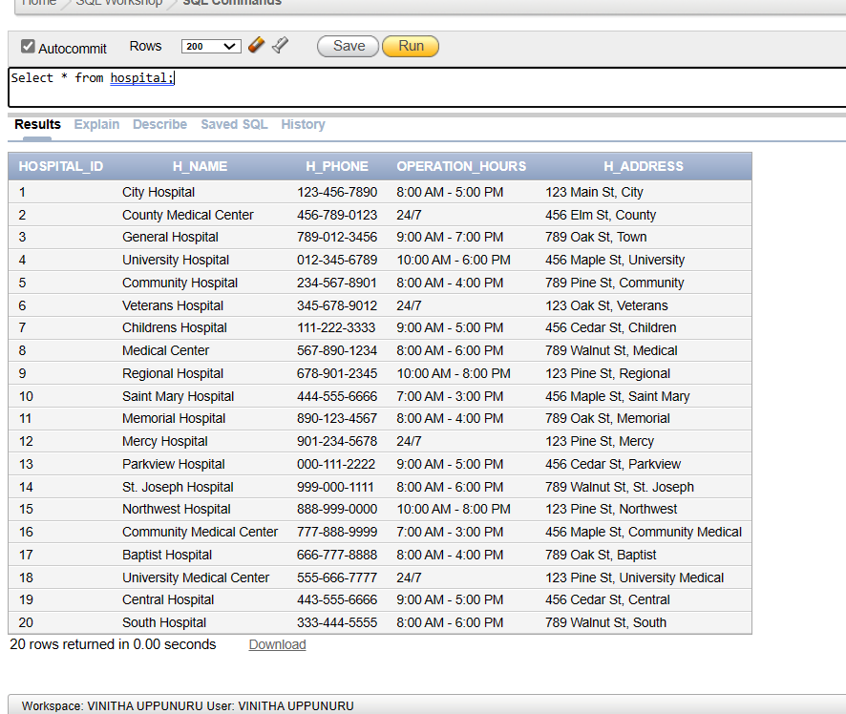

**PATIENT**

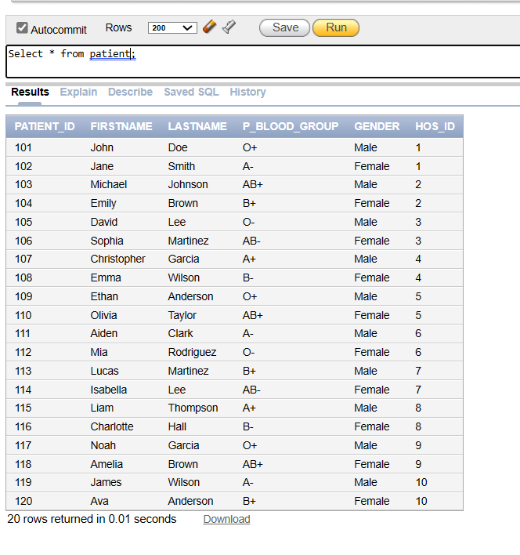

**MOBILE NUMBERS**

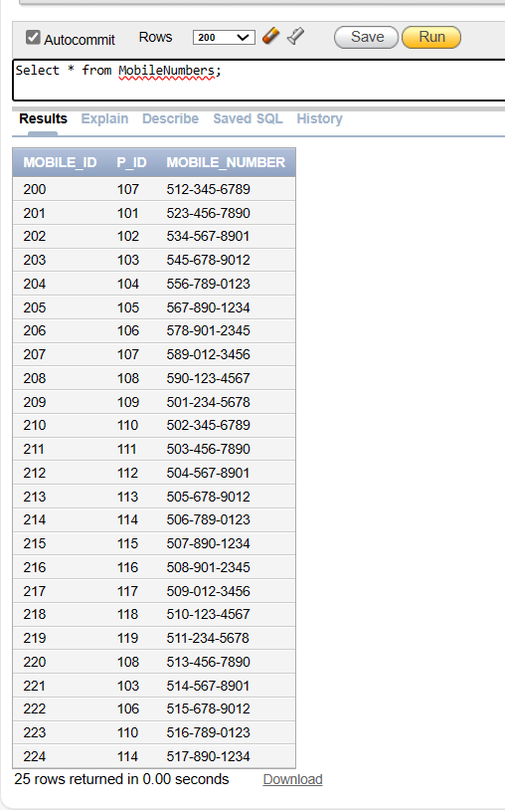

**BLOOD_CAMP**

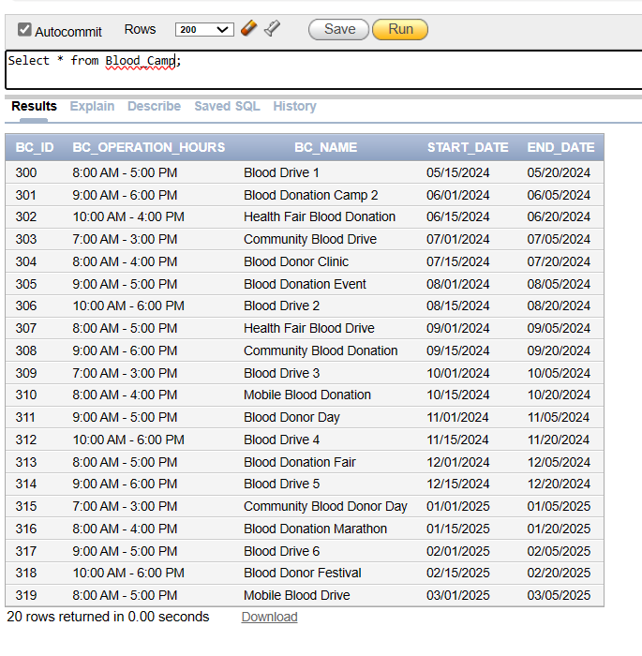

**BLOOD_STORED**

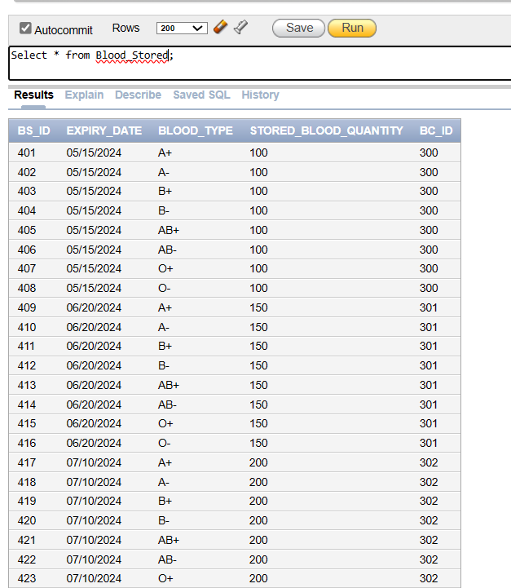

**BLOOD_BANK**

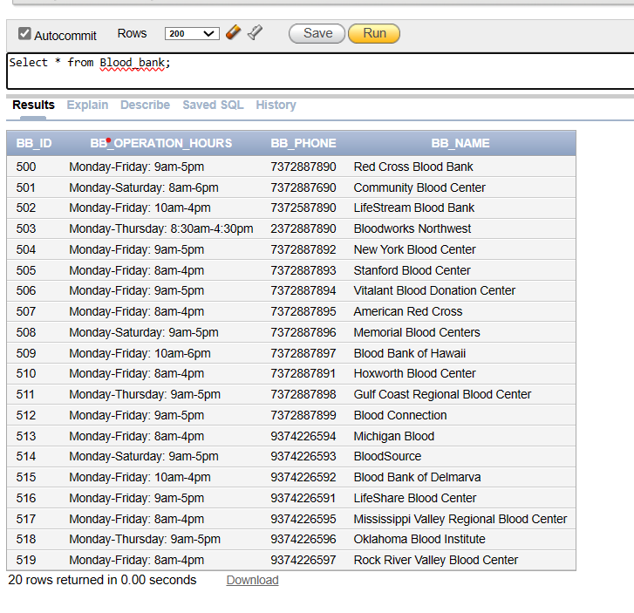

**INVENTORY**

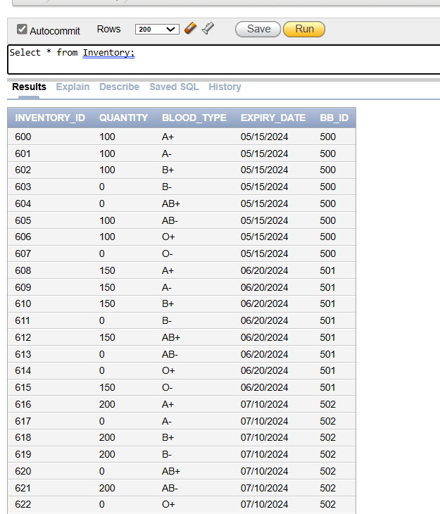

**REQUEST**

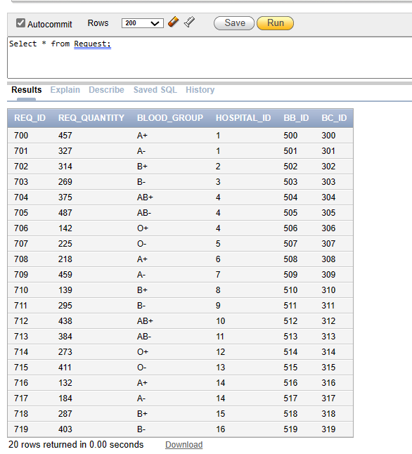

**DONOR**

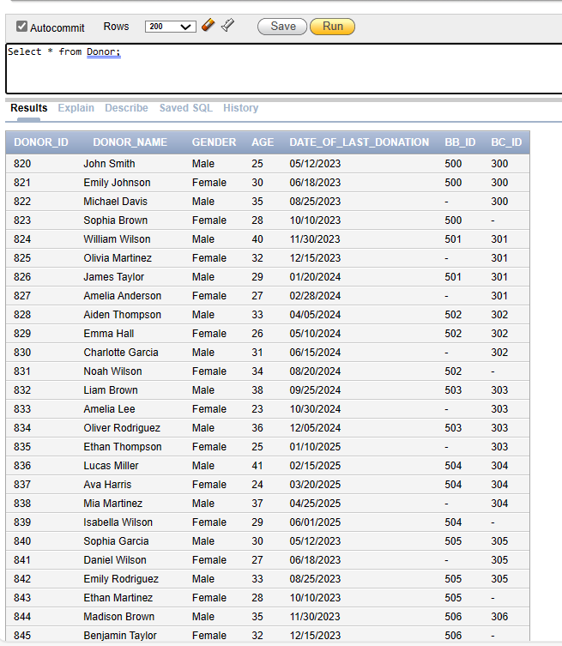

**ADMITS**

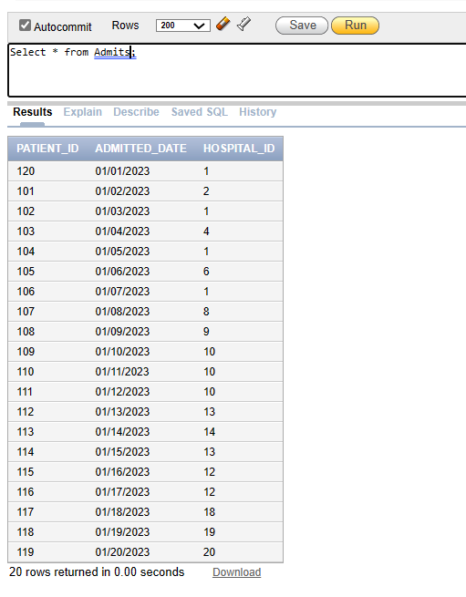

**SEND_TO_BC**

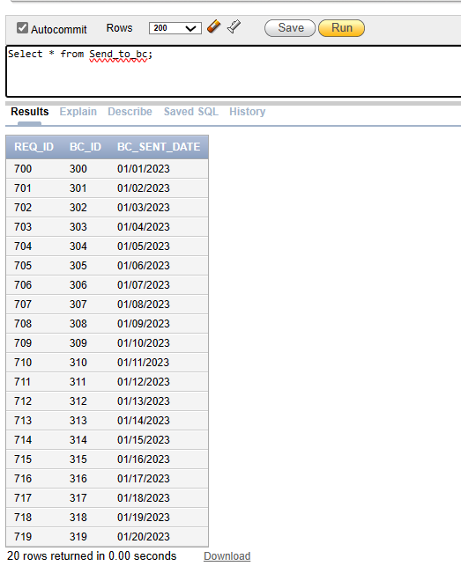

**SEND_TO_BB**

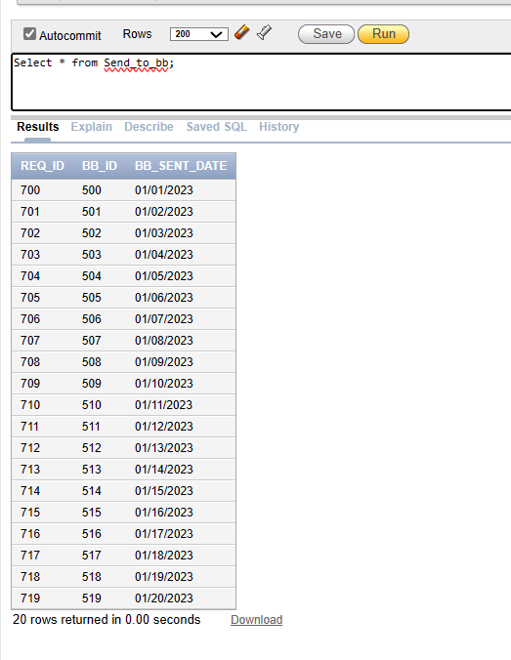

**TRANSACTIONS:**

**1. Query to retrieve the names of all hospitals and their operation hours.**

SELECT h_name AS hospital_name, operation_hours

FROM Hospital;

**Result:**

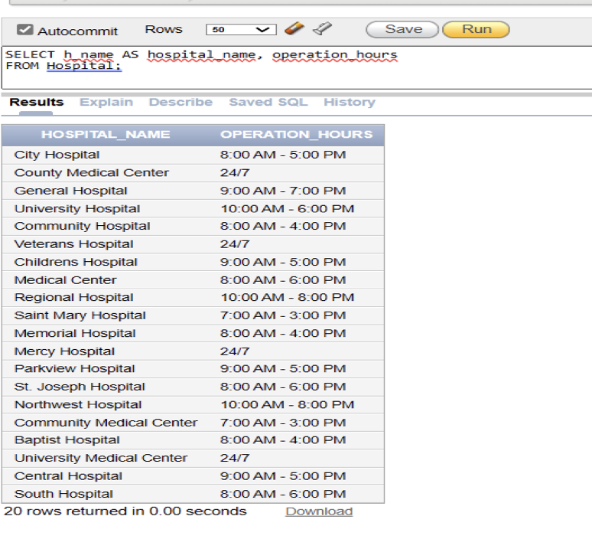

**2. Query to retrieve the names of patients along with the names of the hospitals they are admitted to.**

SELECT p.FirstName || ' ' || p.LastName AS patient_name, h.h_name AS hospital_name

FROM Patient p  
JOIN Hospital h ON p.hos_id = h.hospital_id;

**Result:**

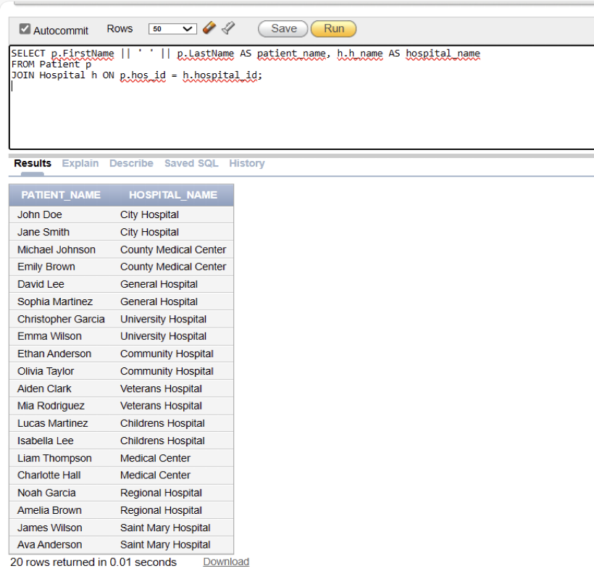

**3. Query to count the number of patients in each hospital.**

SELECT h.h_name, COUNT(p.patient_id) AS patient_count

FROM Hospital h

Patient p ON h.hospital_id = p.hos_id

GROUP BY h.h_name;

**Result:**

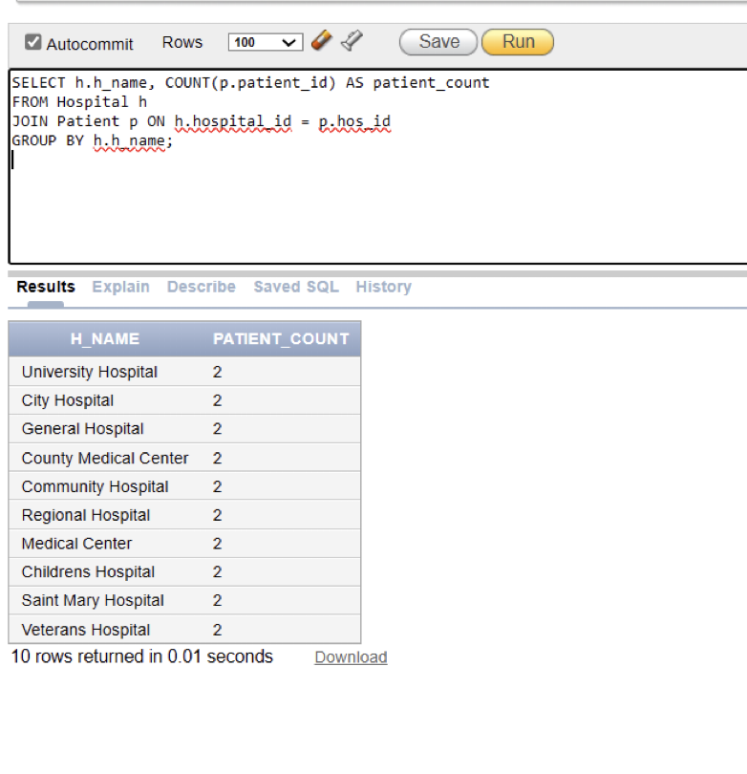

**4. Query to calculate the total blood donation quantity by gender.**

SELECT d.gender, SUM(bs.stored_blood_quantity) AS total_donation_quantity

FROM Donor d

JOIN Blood_stored bs ON d.bc_id = bs.bc_id

GROUP BY d.gender;

**Result:**

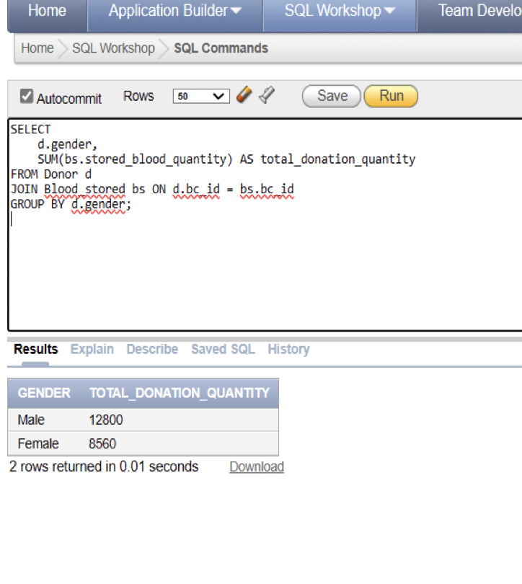

**5. Query to retrieve requested blood groups that are available at specific blood donation camps and provides the names of those camps.**

SELECT DISTINCT bs.blood_type as Requested_blood_group, bc.bc_name as Available_at_blood_camps FROM blood_camp bc,blood_stored bs WHERE bs.bc_id = bc.bc_id AND bs.blood_type in(SELECT DISTINCT r.blood_group FROM request r) AND bs.stored_blood_quantity > 0

GROUP by bs.blood_type,bc.bc_name

ORDER by bs.blood_type;

**Result:**

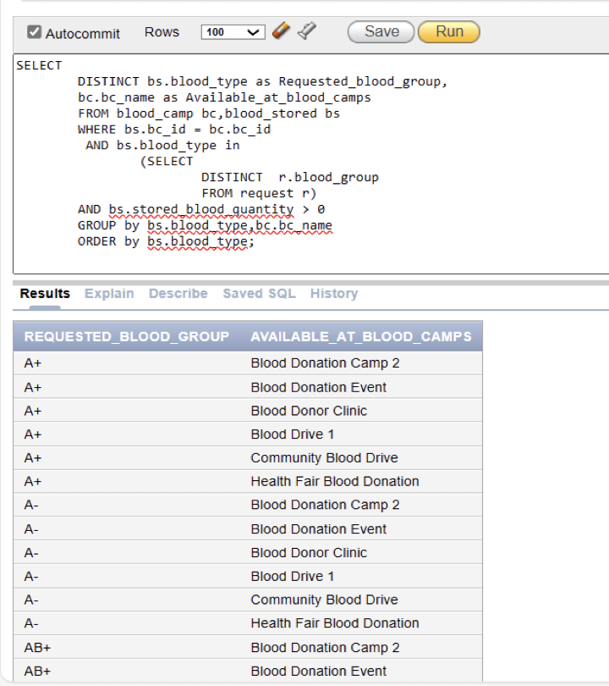

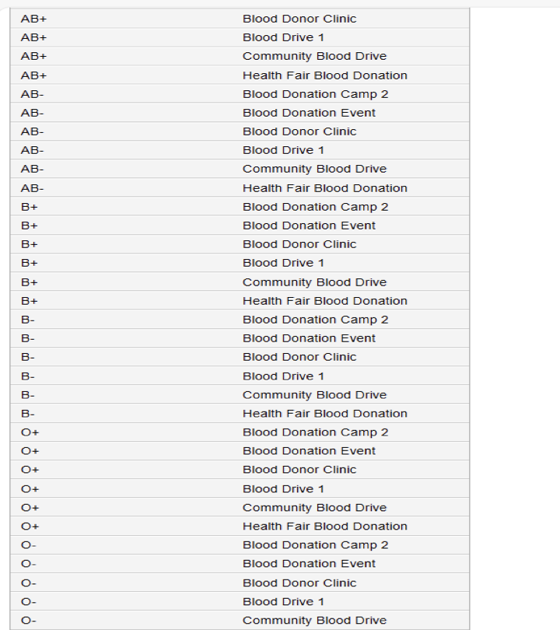

**6. Query to retrieve requested blood groups that are not available at specific blood donation camps and provides the names of those camps.**

SELECT DISTINCT bs.blood_type as Requested_blood_group, bc.bc_name as Not_Available_at_blood_camps

FROM blood_camp bc,blood_stored bs WHERE bs.bc_id = bc.bc_id and bs.blood_type in (SELECT DISTINCT r.blood_group FROM request r) AND bs.stored_blood_quantity = 0 GROUP BY bs.blood_type,bc.bc_name

ORDER BY bs.blood_type;

**Result:**

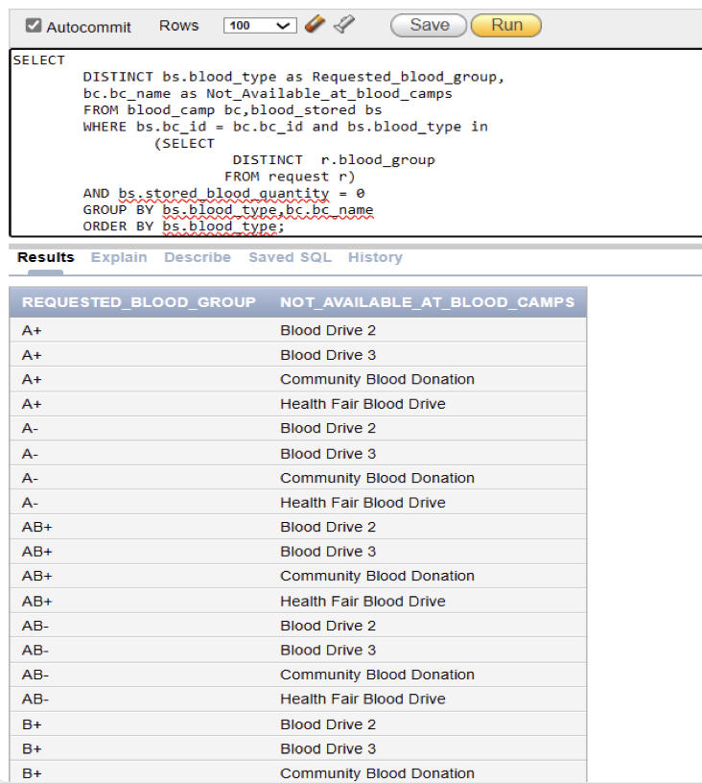

**7. Query to identify blood requests for specific blood group and hospital.**

SELECT r.req_id, r.req_quantity, r.blood_group, h.h_name

FROM Request r

JOIN Hospital h ON r.hospital_id = h.hospital_id

WHERE r.blood_group = 'A+’;

**Result:**

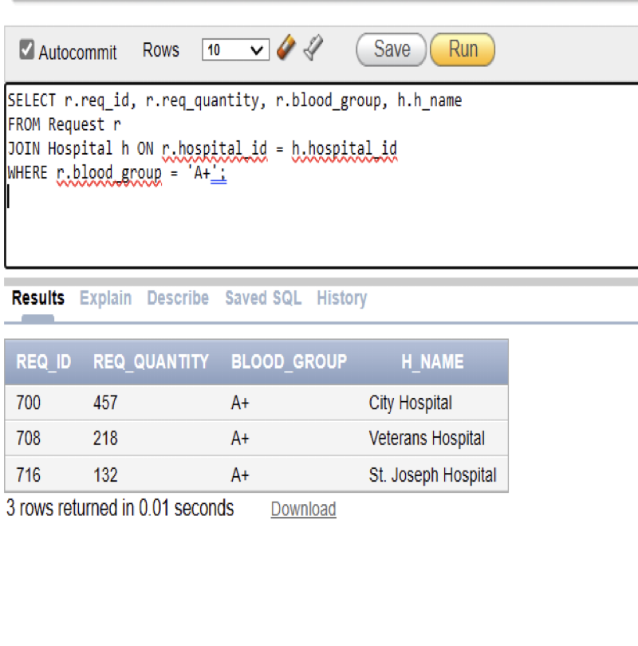

**8. Query to fetch all admissions with corresponding patient and hospital.**

SELECT a.*, p.FirstName AS patient_first_name, p.LastName AS patient_last_name, h.h_name AS hospital_name FROM Admits a

INNER JOIN Patient p ON a.patient_id = p.patient_id

INNER JOIN Hospital h ON a.hospital_id = h.hospital_id;

**Result:**

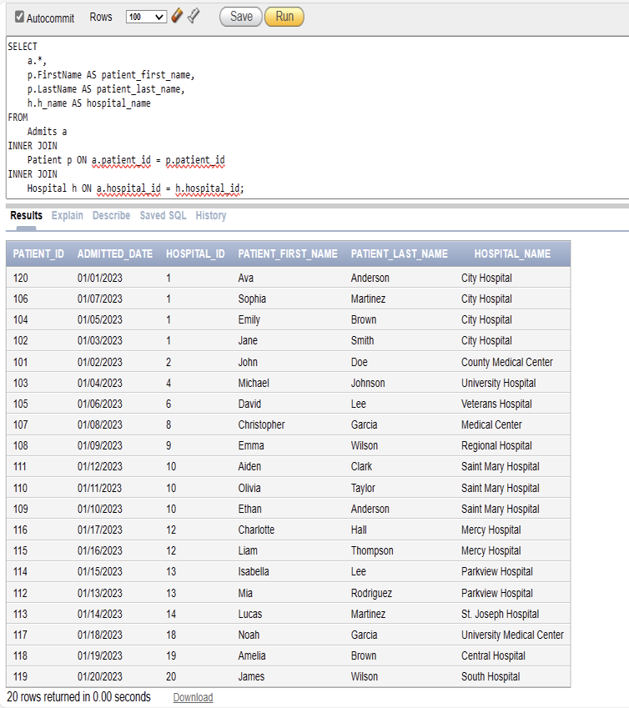

**9. Query to fetch all donors with corresponding blood bank and blood camp.**

SELECT d.*, bb.bb_name AS blood_bank_name, bc.bc_name AS blood_camp_name FROM Donor d

LEFT JOIN Blood_Bank bb ON d.bb_id = bb.bb_id LEFT JOIN Blood_Camp bc ON d.bc_id = bc.bc_id;

**Result:**

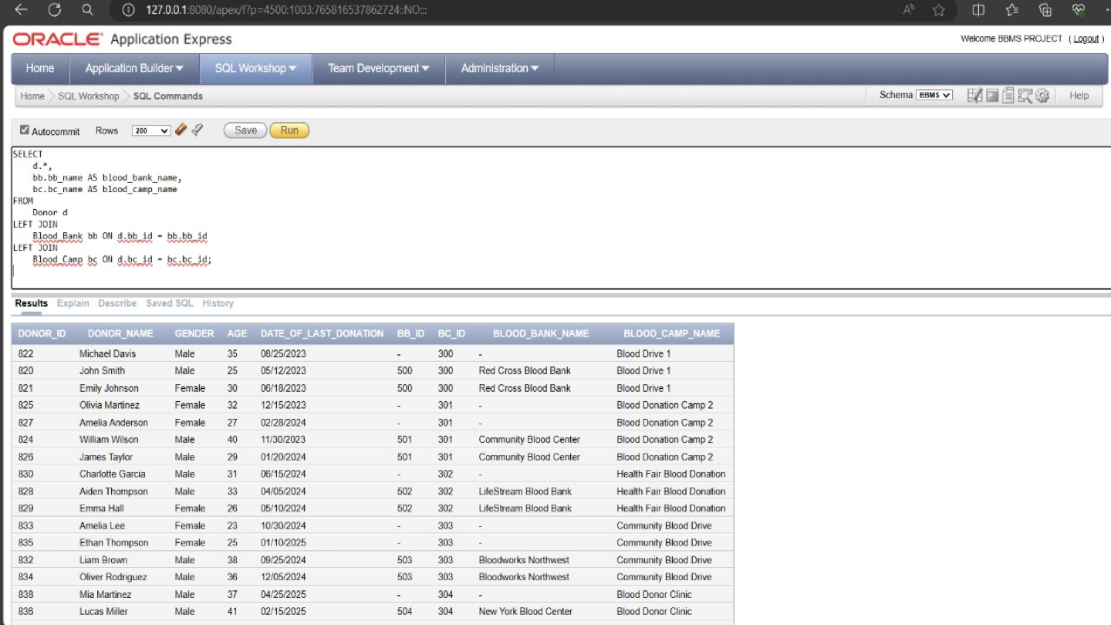

**10. Query to retrieve requested blood quantity, blood group, blood bank name and the request sent date to the blood bank for all the request Id’s.**

SELECT req.req_id, req.req_quantity, req.blood_group, bb.bb_name, stb.bb_sent_date

FROM Request req

JOIN Blood_Bank bb ON req.bb_id = bb.bb_id

JOIN Send_to_bb stb ON req.req_id = stb.req_id;

**Result:**

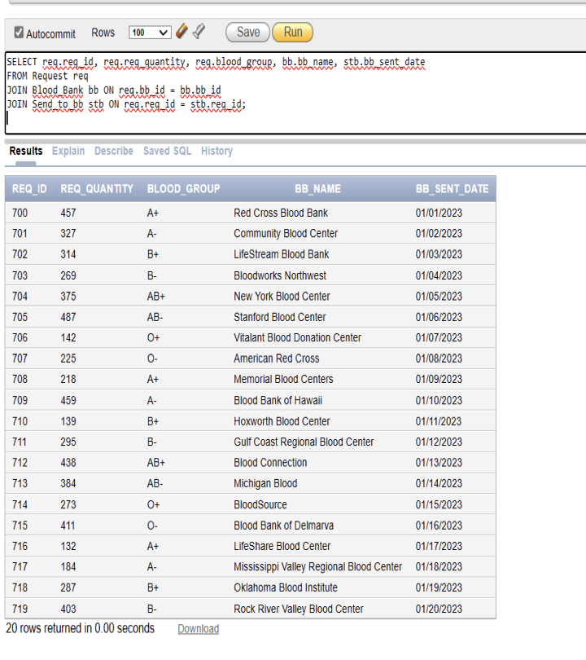

**CONCLUSION**

The Blood Bank Management System stands as a testament to the innovation and dedication of healthcare professionals in optimizing the utilization of limited blood resources. It serves as a vital tool for enhancing operational efficiency and quality within blood banks, empowering organizations to streamline key processes and meet the needs of patients effectively. By adopting systematic approaches to documentation management and leveraging evolving technological landscapes, blood banks can extend their reach, foster ongoing donor engagement, and ensure a steady supply of blood donations. Throughout the development of the blood bank database, challenges were encountered and overcome, leading to the creation of a robust and effective solution that meets the diverse requirements of blood bank management. This project offers valuable insights into the complexities of database development, showcasing the importance of careful planning, thorough analysis, and diligent application of concepts. As the demand for efficient data management and analysis continues to rise in the healthcare sector, the skills and techniques demonstrated in this project will undoubtedly remain invaluable for both students and professionals striving to make a meaningful impact in blood bank management and beyond.